Department of Computer Science

Jamie Birch, Sarah Carter, Ching Chi Chan,

Matthew Ellams, Sam Grant, Alexander Lorimer

___REPORT___

**CODE a**

**COLONY**

MS50 Computer Science Conversion,

Software Development,

Group **B**ees

2016

**Declaration of Mark Distributions**

We hereby declare that the following distribution of marks have been agreed by all of the undersigned, and that the work detailed in this document is the sole product of the group members.

Jamie Birch % __________________________________

Sarah Carter % __________________________________

Ching Chi Chan % __________________________________

Matthew Ellams % __________________________________

Sam Sutherland Grant % __________________________________

Alex Lorimer % __________________________________

# Contents

Contents 3

Abstract 9

Introduction 1.0 10

Computer Science Education 1.1 10

Gender Gap 1.2 11

Industry Stakeholders 1.3 12

Target Audience 1.4 13

Bristol Grammar School, IT Class Focus Group (Pre-development) 1.4.1 13

Aims and Objectives 1.5 16

Concept Development 2.0 17

Initial Concepts 2.1 17

Text Adventure Game 2.1.1 17

CPU Puzzle Game 2.1.2 19

Bee Concept 2.1.3 21

Post Focus-group Concepts 2.2 22

CPU Mario 2.2.1 22

Shrek Themed Game 2.2.2 24

Bee Concept (further developed) 2.2.3 25

Background Research 2.3 26

Relevance and Scope 2.3.1 26

Currently on the Market 2.3.2 27

Scratch 2.3.2a 28

Educational Coding Games 2.3.2b 28

Swarm Manipulation 2.3.2c 29

Final Concept 2.4 31

Unique Selling Points 2.4.1 31

Requirement Specification 3.0 32

Introduction 3.1 32

Overview 3.2 32

Product Components 3.3 32

Opening title screen 3.3.1 32

Audio 3.3.2 32

HUD 3.3.3 32

World and terrain 3.3.4 33

Characters 3.3.5 33

Timed Events 3.3.6 33

Interactive objects 3.3.7 33

Use Characteristics 3.4 33

Dependencies 3.5 34

Constraints 3.6 34

Time 3.6.1 34

Skillset 3.6.2 34

Fair Use and Copyright 3.6.3 34

Divided Focus 3.6.4 34

Quality Assurance 3.7 35

Suitability 3.7.1 35

Efficiency 3.7.2 35

Flexibility 3.7.3 35

Security 3.7.4 35

Maintainability 3.7.5 35

Portability 3.7.6 35

Stability 3.7.7 36

Usability 3.7.8 36

Use Cases 3.8 36

Program operation 3.8.1 36

Block-based programming operation 3.8.2 37

Gameplay 3.8.3 39

Design Implementation 4.0 40

Module Design 4.1 40

Systems Architecture 4.2 41

Graphics 4.3 42

Opening title screen 4.3.1 42

Game world 4.3.2 44

Game objects 4.3.3 45

User interface 4.3.4 45

Audio Design 4.5 46

Core Features 4.6 48

Unit Testing 4.7 48

User Testing 4.8 49

Tools 4.9 51

Collaboration 4.9.1 51

C 4.9.2 51

Media 4.9.3 51

Version control 4.9.4 52

Prototype Design & Experiments 4.9.5 52

Project Management 5.0 54

5.1 Introduction 54

5.1.1 Project Manager 54

5.2 Planning & Scheduling 54

5.2.1 Planning 54

5.2.2 Scheduling 55

5.2.3 Group Meetings 55

5.2.4 Tools 56

5.2.5 Gantt Chart 57

5.3 Version Control 61

5.4 Feasibility Study 61

5.4.1 Technical Feasibility 61

5.4.2 Scheduling Feasibility 61

5.5 Risk Analysis 62

5.5.1 Identifying Risks 62

5.5.2 Risk Management 62

5.5.3 Risk Matrix 63

5.6 Task Allocation 64

5.7 Rescheduling 65

5.8 Evaluation 65

Conclusion 6.0 66

Further Development 6.1 66

Announcement Bar with Story 6.1.1 66

Tutorial Mode 6.1.2 66

B++ Editor Extensions 6.1.3 66

Alternative Skins 6.1.3 66

Additional Theme Tunes/Sound Effects 6.1.4 66

Social Media and Element of Competition 6.1.5 67

Richness of the Open World 6.1.6 67

Bonuses and Boosters 6.1.7 67

Evaluation 6.2 67

Code A Colony 6.2.1 67

Software Engineering Experience 6.2.2 68

Appendix 70

Market research findings 1.0 70

Meetings materials 2.0 75

Meeting one lesson plan 2.1 75

Meeting two questionnaire 2.2 76

Functions documentation 3.0 77

Generic.c 3.1 77

Controls.c 3.2 85

AI.c 3.3 88

World_generation.c 3.4 88

Graphics.c 3.5 88

Contents

Introduction

Background

Aims and Objectives

Target Audience

Definitions

Planning

Concept Development

Market Research

Initial Concepts

Text Adventure Game

CPU Mario

Shrek

Bees

Final Concept

Competitor Analysis

Project Management

Overall Objectives

Planning and Scheduling

Gantt Chart

Tools

Pair Programming

Sprinting

Unit testing

Version Control

Continuous Integration

Rescheduling

Evaluation

Design and Implementation

Initial Design

Risk Assessment

Task Allocation

Final Design

Testing and Debugging

Future Development

Results and Feedback

Testing Feedback

Results

Evaluation

Individual Evaluation

Appendix

Meeting Minutes

References

# Abstract

Code A Colony is a game that gives players significant control over a colony of bees. This colony can exhibit complex, collective behaviors determined by player-constructed algorithms. Targeted at Key Stage 3 level students, the aim is to develop and reinforce computing skills that have become a statutory part of the UK curriculum as of September 2014 (with a significant focus on the application of logic and algorithmic problem solving).

We have designed the game to allow players to experiment with custom problem solving/swarm intelligence algorithms, within a graphically rich, interactive context. The bees have an intuitive API, and are endowed with a small amount of memory along with an ability to conditionally interact with both their local environment and with neighboring bees. The controlling algorithm is constructed and manipulated by the player graphically, represented as visual connections between selected nodes (which represent functions) within a graph.

This report details the research, development and management that went into the Code A Colony project, while also documenting our experiences of the agile software development processes we employed.

# Introduction 1.0

Technology has changed the way in which we live our everyday lives, from communicating with friends all over the world with a simple click, to the way in which we find a new recipe, or even how we navigate from A – Z. Computers have emerged as ubiquitous devices; increasingly powerful, portable, and intuitively interactive. But this apparent simplicity belies their growing complexity and sophistication. Few of us are capable of seeing past the opacity of modern computers, to reason about their underlying technologies, despite the vast majority of the population relying on digital technology daily.

In the 1980s - at the very cusp of the personal computer revolution - a gap in the computer literacy of the public had been noticed. This provoked the BBC’s Computer Literacy Project and the launch of the BBC Micro (a personal computer designed for computing education). As described by the project editor David Allen, *“The aim was to democratise computing. We didn’t want people to be controlled by it, but to control it.”*[1] This initiative introduced millions of children to the field of computing, and inspired a generation of computer scientists and engineers.[2]

Yet growing concerns still exist, revolving around a disparity between computing education and the demands of the industry. In 2011 Eric Schmidt (then Chairman at Google) criticised Britain’s education system, stating *“your IT curriculum focuses on teaching how to use software, but gives no insight into how it is made.”*[3] Inspired by the success of the BBC Micro, and fueled by the current discourse surrounding computer science education, this report details our attempt at designing and implementing a system to educate and inspire Key Stage 3 level school children about digital technology. The intention is to help demystify core computing concepts to a new audience, reinforcing recent statutory changes to the national curriculum regarding computer science education.

## Computer Science Education 1.1

In September 2013 the UK Department for Education published a document explaining significant changes to the national curriculum, with a legislative move (at Key Stage 3 level, and earlier) away from general “ICT” and the use of common software, towards teaching students to *"apply the fundamental principles and concepts of computer science, including abstraction, logic, algorithms and data representation."[4]* A central goal of this reform is to ensure that all pupils, *“can analyse problems in computational terms, and have repeated practical experience of writing computer programs in order to solve such problems.”*[5]

Before these changes came into effect in September 2014, concerns about a lack of appropriately skilled teachers prompted millions in investment (from both public and private sources) towards computer science training programmes for secondary school teachers.[6] Never-the-less, in December 2015 the chief of the British Computing Society (appointed by the government to lead these reforms) stated that teachers are still struggling with the new curriculum, and that it could be another five years until it will be successfully taught[7] across the country.

A significant problem appears to be that not all schools are fortunate enough to have access to specialist, appropriately qualified staff. Government investment continues to be aimed at increasing the number of “master” computing teachers, but these targets continue to be missed.[8] Additionally, with roughly 60% of parents not aware of the new curriculum’s introduction in 2014,[9] support for computer science appears to be limited both as school and at home. Additionally the ratio of girls to boys who decide to study computer science at GCSE level is shockingly low.

## Gender Gap 1.2

Computer science as a subject at GCSE level in 2014 was significantly less popular than ICT. This may have been influenced by initial implementation problems. Nevertheless, the average ratio of girls to boys in computer science cohorts was significantly less than in ICT (see graphs below). Despite this, as part of further reforms, the government announced plans in November 2015 to scrap GCSE and A-Level ICT altogether. The intention is to cast more focus on computer science. As stated in the original document, ministers have “taken the decision not to approve two GCSEs and A levels in a similar qualification space. The IT GCSE and IT A level will not be redeveloped.”

*Statistics collated Joint Council for Qualifications ‘Results 2015’ http://www.jcq.org.uk/Download/media-centre/news-releases/gcse-press-notice---wales*

This has sparked significant debate,[10] largely hinging on concerns about further alienation and narrowing of the curriculum for girls.

*Statistics collated Joint Council for Qualifications ‘Results 2015’ http://www.jcq.org.uk/Download/media-centre/news-releases/gcse-press-notice---wales*

*Statistics collated Joint Council for Qualifications ‘Results 2015’ http://www.jcq.org.uk/Download/media-centre/news-releases/gcse-press-notice---wales*

## Industry Stakeholders 1.3

The recent computing focused curriculum reforms were instigated largely by pressure from tech industry leaders,[11] asserting that significant change will be essential if the UK is to remain globally competitive in certain computer-focused disciplines. Next Gen, for example, is a report published in 2011, strongly recommending reforms the UK curriculum to bring computer science in as an essential discipline.[12] The Next Gen report was responding to declining national competitiveness in the computer game and visual effects industries, along with concerns about increasingly “having to source talent from overseas because of skills shortages at home.”[13]

The report also strongly recommended the appointment of “the best teachers to teach computer science”, and the use of gaming and visual effects within classrooms, suggesting, “Schools harness the ‘cool factor’ and technology potential of video games and visual effects to draw in more young people to computer science.”[14] It is too early to see the industry ramifications of the reforms to the national curriculum, but so far the indications are that the classroom learning experience has not been enough to effectively draw children in, particularly the girls.

## Target Audience 1.4

While secondary market research has acted to inform our motivations for this project, our efforts in the development of Code A Colony have been guided significantly by primary market research. We have tried (where possible) to engage directly with Key Stage 3 educators as well as a user sample of our target audience (year 9 students of Bristol Grammar School, aged 13–14, both male and female). This has acted as an invaluable source of information, while allowing us to practice the agile programming concept of short feedback cycles.

### Bristol Grammar School, IT Class Focus Group (Pre-development) 1.4.1

An initial visit to the school took place on Thursday 8th October, in which we were granted an hour for a focus group with year 9 pupils. For this we devised a series of activities designed to acquire information about IT education, along with opinions and preferences regarding computer games (as well as other topics).

During the first 5 minutes we introduced ourselves and engaged in a class discussion about what the pupils had been doing and learning so far in terms of computer programming. The answers **ranged significantly**, from having little experience at all, to actively engaging in interesting web-scripting projects. We were also introduced to their use of Scratch, **a visual programming language**. This came acted as a great source of inspiration for our project.

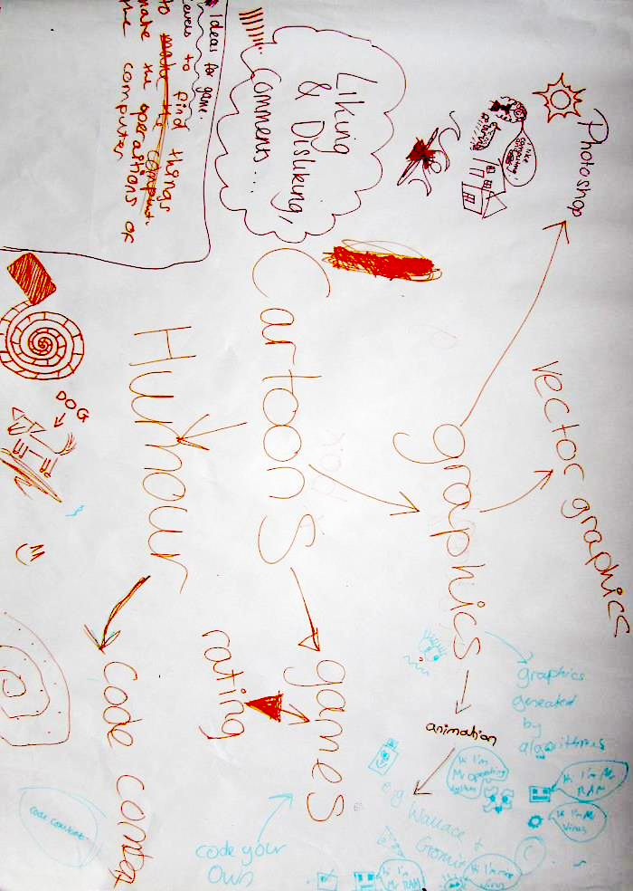

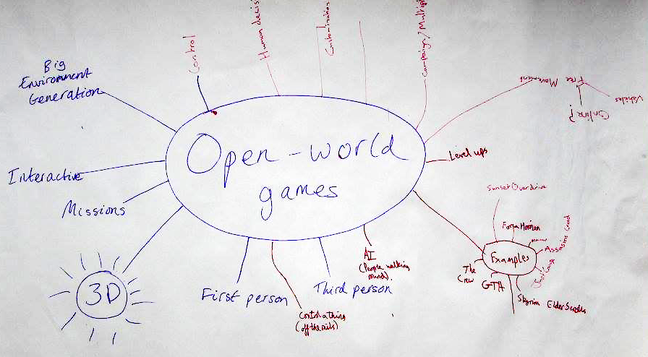

We then divided the class into four lines and set up a relay game where the first person in each line ran up to the front of the class to write an interest on an A2 sheet of paper. After several minutes the group with the longest list would win. We then handed out coloured stickers to each pupil and asked them to place a sticker next to the three interests that they prefer (on any amongst the 3 other teams' sheets of paper). This allowed us to get a ranking of the most common interests, while sparking class discussion.

We subsequently organised them into smaller groups, asking each to pick an interest and brainstorm possible connections to the field of computer science. Finally, we asked the groups to design a game relating to this interest, keeping in mind that it must include an educational computer science element. Pupils were encouraged to draw mind maps, and these materials can be found in Appendix 1. The results from these activities are listed below.

Class Discussion & Groups Concepts

* Emphasis on interactive, **explorable**, non-static, **‘open worlds’**
* Connection to **cartoons**, and perhaps recognisable characters
* ‘Mario’ concept , where a player **collects blocks of code** and has to figure out what order they should go in before handing to the CPU
* Importance of **story**-based progression

Pen Relay Game

Highest Ranking Interests

* South Park (4)
* Xbox (4)
* Hockey (3)
* Family Guy (2)
* Football (2)
* FPS CoD / cs:go (2)
* GTA-game (2)
* Open world games (2)
* Rugby (2)
* Antelopes (1)
* Caramel (1)
* Phone (1)
* Shrek (1)
* Social Media (1)
* Strategy (1)

Cartoons

Digital Technology

Sport

Commonalities

In addition to these activities, we also asked pupils to fill out a questionnaire at the end of the class, ranking twelve game aspects in terms of importance to their experience (see pie chart below; ranks on next page).

Game Aspect Questionnaire (out of 10 – lowers scores rank most highly)

| **Category** | **Combined score** |  | **Rank** |
| --- | --- | --- | --- |
| Graphics | 38 |  | 1 |
| Story | 43 |  | 2 |
| Competing with others | 61 |  | 3 |
| Constant interaction | 68 |  | 4 |
| Innovation | 75 |  | 5 |
| Characters | 76 |  | 6 |
| Cooperation with others | 77 |  | 7 |
| Single player gameplay | 91 |  | 8 |
| Checkpoints | 94 |  | 9 |
| Levelling up | 96 |  | 10 |
| Sound design | 105 |  | 11 |
| Replayability | 115 |  | 12 |

The main insights we gained and took forward from these activities were that:

* **Cartoons and comedy** seem to be a useful tool to make game ideas more appealing. Game characters that are caricatured, and themes/challenges that contain an element of humor could be useful devices to draw in our target audience.
* **Story- / stage-based progression** (“levelling up”) was also a very popular concept. This could in some way be tied to an aspect of humour, but also would be very useful in the form of a progressive tutorial.
* **Game environments** that can be **openly navigated**, and freely explored and interacted with are important.
* A sense of **collecting items, points, or “code blocks”** could act as the main challenge, allowing for some element of competition (competing against your previous score, or the score of a friend).

Bristol Grammar School, meeting with the Head of IT (Pre-development) 1.4.2

On top of our detailed discussions with school pupils, we were also granted a 30 minute meeting with Amy Finney, the head of IT at Bristol Grammar School. Her very informative insights regarding the development of a computer science education game can be summarised in three key points.

The game should be:

**FORGIVING**/robust: “If it is too difficult, and too easy to make mistakes, they will lose interest”. (Block-based scripting like Scratch is very good for this!).

It should be **RESPONSIVE**, (i.e. have instant results): “If the children don’t see the results of what they’re doing very quickly, then they will lose interest”. That is to say, we should avoid having long periods where users have to work on code with nothing else happening.

It should have **DEPTH:** “Users will have all sorts of different skill levels – try to appeal to more than just the most experienced users”. We should thus ensure that the game avoids becoming one-dimensional and has variety in the challenges.

The teacher also took us through an introduction to Scratch, which will be detailed in section “…“ (Currently on the Market). She emphasised the range of different ability and skill levels of pupils within the school, in terms of programming. She also mentioned a large disparity between schools, in terms of the amount of focus given to programming and contemporary computer science education.

## Aims and Objectives 1.5

Code A Colony is intended to reinforce and supplement computer science topics that have become a fundamental part of the national curriculum at Key Stage 3. Affecting real change means reaching homes as well as schools, and for this reason, we have focused our efforts purely on software (as opposed to costly hardware) for the creation of an engaging, educational game. Guided by our research findings, we have isolated a series of aims:

* To develop gender-neutral concepts (in terms of theme and graphics) that should appeal to girls, as much as boys (applying elements of humour and cartoon style graphics as a source of common interest).
* To establish a framework into which progressive stories, challenges and tutorials could be easily added and extend.
* To produce a visually rich, responsive game, with sufficient depth to be enjoyed by children with more coding experience, while being accessible (and forgiving in nature) to absolute beginners.

Our overall objective is to demystify computer science to Key Stage 3 children, and to empower them to *“analyse problems in computational terms”*[15] through building a simple understanding of algorithms and Boolean logic (key objectives as defined by the recent UK curriculum reforms). A secondary objective is to finish a well-polished, playable prototype of this game by the necessary deadline (22/01/26).

# Concept Development 2.0

## Initial Concepts 2.1

We began to develop concepts for this project while gathering secondary research on the state of computer science education. The three that are briefly present in this section (Text Adventure Game, CPU Puzzle Game and Bee Game) were simple concepts proposed before our focus group at the Bristol Grammar School. We have applied SWOT analysis in light of our focus group discussions. In section 2.2 (Post Focus-group Concepts) we will show how this allowed the ideas to morph and develop significantly, with some sub-concepts even proposed directly by the pupils.

### Text Adventure Game 2.1.1

An early concept proposed was a text based adventure game, with the idea that many different scenarios and themes would be easy to produce after establishing a general framework. The idea was to introduce players to programming in a context of their choice; being able to control a Rock Star on tour, a soldier in a zombie apocalypse or a wizard fighting enemy trolls. Players would control these characters in the context of a story, making decisions for that character using general programming syntax and terminology (employing functions that take variable arguments). As an example, a character might be moved left or right, or instructed to defend itself against a specific enemy.

The zombie wants to eat your brains… what do you do?

setSpeed(MAX_SPEED);

run(LEFT_

API

The decisions made by the player would allow them to either progress through the game, reaching harder challenges, or move them back in the game to less sophisticated problems. In this way the game would accommodate both beginners and children with more experience.

|  |  |
| --- | --- |
| Strengths   * Story element highlighted as important by target audience * Easily extensible and customisable themes, with potential to target both boys and girls * **Could be developed to teach the application of a** wide range of computing concepts * **Could be developed to allow players to create their own story lines and challenges.** | Weaknesses   * Difficult to implement enough graphics to enhance **the** game **and support many different themes and scenarios** * Lack of competitive element **(or concept of score)** important to **the** target audience * Unlikely to **spark** **enthusiasm** for the target audience |
| Opportunities   * **Role playing games have been hugely successful in the past (Monkey Island, Dungeons & Dragons)** | Threats   * **Concept** is unoriginal and outdated compared to modern games that are highly accessible |

### CPU Puzzle Game 2.1.2

The concept attempted to flip the relationship between programmer and computer around, as a novel approach to this project. The idea is that program instructions would be displayed to the player, who would need to act analogously to a Central Processing Unit (and its output and storage peripherals) to interpret these instructions, and perform the correct actions to complete tasks. An example would be to move objects into instructed positions, or colour objects correctly, etc.

As the game progresses, in order to increase difficulty, lower level instructions could be used to reduce the level of abstraction and proximity to human language. At the lowest levels of abstraction (/highest levels in the game), an ability to interpret hex and/or binary would be required to perform actions correctly.

int x = 10;

int y = 6;

moveSquareTo(bigSquare, x, y * 2);

|  |  |  |  |  |  |  |  |  |  |  |  |  |  |  |  |  |  |  |  |  |  |  |  |  |  |  |  |  |  |  |  |
| --- | --- | --- | --- | --- | --- | --- | --- | --- | --- | --- | --- | --- | --- | --- | --- | --- | --- | --- | --- | --- | --- | --- | --- | --- | --- | --- | --- | --- | --- | --- | --- |
|  | 0.. | 2.. | 3.. | 4.. | 5.. | 6.. | 7.. | 8.. | 9.. | 10 | 11 | 12 | 13 | 14 | 15 | 16 | 17 | 18 | 19 | 20 | 21 | 22 |  |  |  |  |  |  |  |  |  |
| 0 |  |  |  |  |  |  |  |  |  |  |  |  |  |  |  |  |  |  |  |  |  |  |  |  |  |  |  |  |  |  |  |
| 1 |  |  |  |  |  |  |  |  |  |  |  |  |  |  |  |  |  |  |  |  |  |  |  |  |  |  |  |  |  |  |  |
| 2 |  |  |  |  |  |  |  |  |  |  |  |  |  |  |  |  |  |  |  |  |  |  |  |  |  |  |  |  |  |  |  |
| 3 |  |  |  |  |  |  |  |  |  |  |  |  |  |  |  |  |  |  |  |  |  |  |  |  |  |  |  |  |  |  |  |
| 4 |  |  |  |  |  |  |  |  |  |  |  |  |  |  |  |  |  |  |  |  |  |  |  |  |  |  |  |  |  |  |  |
| 5 |  |  |  |  |  |  |  |  |  |  |  |  |  |  |  |  |  |  |  |  |  |  |  |  |  |  |  |  |  |  |  |
| 6 |  |  |  |  |  |  |  |  |  |  |  |  |  |  |  |  |  |  |  |  |  |  |  |  |  |  |  |  |  |  |  |
| 7 |  |  |  |  |  |  |  |  |  |  |  |  |  |  |  |  |  |  |  |  |  |  |  |  |  |  |  |  |  |  |  |
| 8 |  |  |  |  |  |  |  |  |  |  |  |  |  |  |  |  |  |  |  |  |  |  |  |  |  |  |  |  |  |  |  |
| 9 |  |  |  |  |  |  |  |  |  |  |  |  |  |  |  |  |  |  |  |  |  |  |  |  |  |  |  |  |  |  |  |
| 10 |  |  |  |  |  |  |  |  |  |  |  |  |  |  |  |  |  |  |  |  |  |  |  |  |  |  |  |  |  |  |  |
| 11 |  |  |  |  |  |  |  |  |  |  |  |  |  |  |  |  |  |  |  |  |  |  |  |  |  |  |  |  |  |  |  |
| 12 |  |  |  |  |  |  |  |  |  |  |  |  |  |  |  |  |  |  |  |  |  |  |  |  |  |  |  |  |  |  |  |
| 13 |  |  |  |  |  |  |  |  |  |  |  |  |  |  |  |  |  |  |  |  |  |  |  |  |  |  |  |  |  |  |  |

|  |  |
| --- | --- |
| Strengths   * An interesting/original game concept, flipping the human/computer relationship around * Player is able to learn about lower level computing concepts, and computer architecture, in addition to higher level programming syntax | Weaknesses   * Novelty may wear off quickly * Relatively static puzzles and repetitive context may become boring * No interactive explorable world, though deemed as important to our focus group * Doesn’t allow players to become familiar with the concept of writing programs themselves |
| Opportunities   * Teaching children more about the complex interaction between the hardware components inside computers fills a gap in the new curriculum (more focused on software and data representation) | Threats   * There are many, many puzzle and brain teaser games on the market. It may be **difficult to compete** without a better source of differentiation |

### Bee Concept 2.1.3

This concept was the earliest form of our Code A Colony game, and was sparked simply from a discussion about our team name, The Bees (Group B). The concept is that a player would be able to program instructions into a colony of bees, telling them where to find resources and what to do with them (such as bringing them back to the hive to earn points). With a large number of bees carrying out player defined instructions, interesting patterns might emerge, resulting in a game that is interesting to watch as well as to directly control.

|  |  |  |  |  |  |  |  |  |  |  |  |  |
| --- | --- | --- | --- | --- | --- | --- | --- | --- | --- | --- | --- | --- |
|  |  |  |  |  |  |  |  |  |  |  |  |  |
|  |  |  |  |  |  |  |  |  |  |  |  |  |
|  |  |  |  |  |  |  |  |  |  |  |  |  |
|  |  |  |  |  |  |  |  |  |  |  |  |  |
|  |  |  |  |  |  |  |  |  |  |  |  |  |
|  |  |  |  |  |  |  |  |  |  |  |  |  |
|  |  |  |  |  |  |  |  |  |  |  |  |  |
|  |  |  |  |  |  |  |  |  |  |  |  |  |
|  |  |  |  |  |  |  |  |  |  |  |  |  |
|  |  |  |  |  |  |  |  |  |  |  |  |  |
|  |  |  |  |  |  |  |  |  |  |  |  |  |

setBeeDest(bee[4], 30, 9);

harvestFlo

Rather than significantly morphing into a new idea, this concept has only been added to since our initial focus group at Bristol Grammar School. A SWOT analysis for this idea, in its further developed form, will therefore be presented in the following section (2.2 Post Focus-group Concepts)

## Post Focus-group Concepts 2.2

Towards the end of our initial focus group at Bristol Grammar School, we each walked around discussing elements of our initial concepts with groups of pupils (in addition to the ideas that they had been brainstorming). Some groups were able to combine these initial concepts with their own ideas, resulting in interesting game proposals that proved popular with the rest of the class.

Additionally, before leaving we presented the basic idea of our bee concept. This was met enthusiastically, with pupils mentioning how they think the idea could be improved. The following three concepts are the result of this interaction with our focus group.

### CPU Mario 2.2.1

CPU Mario is an idea largely proposed by the pupils, in which a player would explore a “Mario” style world, but instead of collecting coins they would collect different parts of a program or instruction. Once the full instruction has been collected, the player would make their way to the CPU, placing the code fragments in the correct order and performing appropriate actions to progress to the next level. This concept incorporates elements of our early CPU Puzzle Game idea, but also extends it to include an **explorable world** with game characters. The idea proved to be very popular with the majority of the class, both girls and boys (having been proposed by a group of girls).

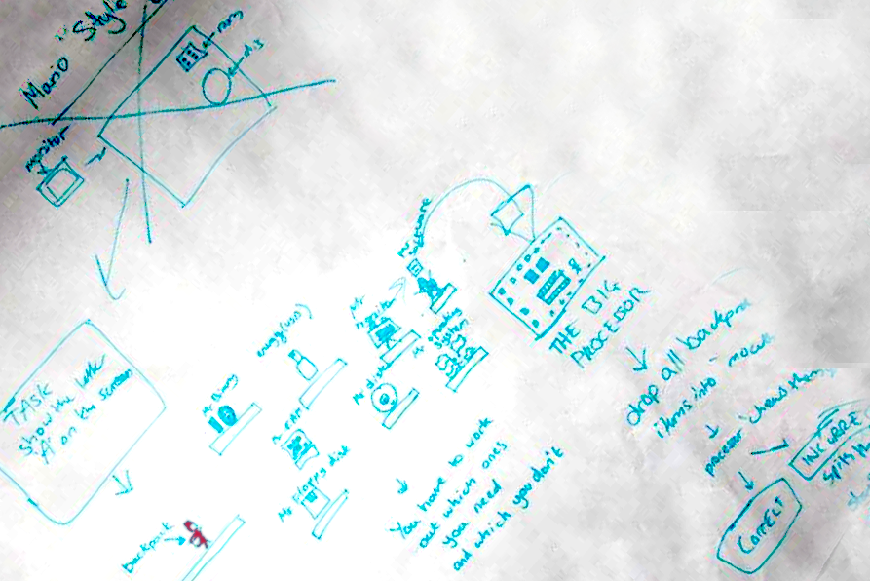

|  |  |
| --- | --- |
| Strengths   * Interesting twist on an otherwise familiar and popular format would make this easy for new-comers to engage with * Does not put the educational subject matter at the forefront. Fun game mechanics would draw players in * Difficulty levels could be easily manipulated to suit differing abilities without altering the nature of the game | Weaknesses   * Platforming concept is slightly passé, 30 years on from its popularization * It might difficult to differentiate our product in a sea of Mario clones * Would require massive effort in level design to give the necessary game depth, which might detract from the more fundamental programming element of the project |
| Opportunities   * Primary research indicates excitement about the concept from our sample group, which will be will be key to captivating our target audience * Could allow for player designed levels, potentially reducing our overall work load | Threats   * **Copyright issues** (if spun-off directly from Mario) * Player designed levels would require the design of a user-friendly level editor, and **requires initial time investment** from early adopters which isn’t guaranteed |

### Shrek Themed Game 2.2.2

This is another idea that was proposed largely by the pupils, but which also represents progression from our earlier text adventure game (by the inclusion of graphics and individual mini-games/missions). Our sample group voted Shrek as one of their top interests, and some of the students put forth a Shrek themed mini game series. The players would control Shrek’s actions using an appropriate API. The entire story of the game would be subdivide into separate missions and mini-game tasks that exercise a range of programming skills and concepts.

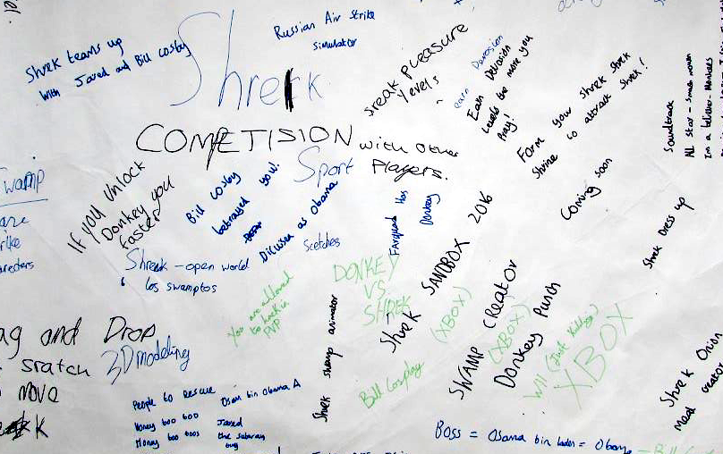

|  |  |
| --- | --- |
| Strengths   * The character featured in the game ranked highly amongst our target audience * Story element highlighted as important by target audience | Weaknesses   * Time constrictions would make it difficult to produce a varied mini game series effectively |
| Opportunities   * Varied mini games allow us to appeal to the interests and learning techniques of a range of students (if they do not learn from one game, they may relate to the format of another) | Threats   * **Copyright issues** (if spun-off directly from Shrek) |

### Bee Concept (further developed) 2.2.3

During our discussion of the Bee concept at the end of the focus group, it became apparent that we could incorporate many elements of the pupils’ ideas into this concept, while effectively responding to the advice of the Head of IT at the school, in terms of game depth and responsiveness. Giving players control over a large colony, where simple instructions will have wide ramifications, means that the player will be able to identify the results of their actions quickly. With a clever arrangement of instructions, sophisticate swarm behaviors could be achieved, giving enough depth to allow more experienced individuals to explore and have fun.

|  |  |  |  |  |  |  |  |  |  |  |  |  |
| --- | --- | --- | --- | --- | --- | --- | --- | --- | --- | --- | --- | --- |
|  |  |  |  |  |  |  |  |  |  |  |  |  |
|  |  |  |  |  |  |  |  |  |  |  |  |  |
|  |  |  |  |  |  |  |  |  |  |  |  |  |
|  |  |  |  |  |  |  |  |  |  |  |  |  |
|  |  |  |  |  |  |  |  |  |  |  |  |  |
|  |  |  |  |  |  |  |  |  |  |  |  |  |
|  |  |  |  |  |  |  |  |  |  |  |  |  |
|  |  |  |  |  |  |  |  |  |  |  |  |  |
|  |  |  |  |  |  |  |  |  |  |  |  |  |
|  |  |  |  |  |  |  |  |  |  |  |  |  |
|  |  |  |  |  |  |  |  |  |  |  |  |  |

stingPicnicPerson(32, 12, NO_MERCY);

collectFood();

Additionally, the idea of collecting blocks of code and arranging them in the correct order is something that would be easy to incorporate. This would also allow us to move away from a text-based editor, to more of a Stratch related, graphical programming system (see Currently on the Market 2.3.2). Mini-games could be included to the extent that a variety of challenges could be added, while also being presented in the context of a progressive story. Humourus challenges, such as stinging people to steal their food, could make the game more appealing (this has been indicated by our research findings).

|  |  |
| --- | --- |
| Strengths   * Capacity for a high degree of game play depth and responsiveness * Potential for complex colony behaviours provides more scope for an interesting and flexible programming interface * Casts more attention on the players developing interesting control algorithms, supporting aim of national curriculum | Weaknesses   * Time constrictions may become an issue if we attempt to incorporate mini-game challenges and an element of story |
| Opportunities   * Story and mini-game/challenge elements proposed in other ideas can easily be included | Threats   * Players may find it difficult to establish effective swarm behaviours and could **lose** interest if too difficult |

## Background Research 2.3

Given the positive response this concept received at the school, and the potential for incorporating concepts and ideas from the pupils, the programmable bee concept became our top choice and the focus of further research and development.

### Relevance and Scope 2.3.1

Algorithms are a key feature of the reformed national curriculum at Key Stage 3, and our bee colony concept is uniquely placed to explore this topic. Autonomous problem solving/learning algorithms control and influence many aspects of society, from weather forecasting to stock trading activity,[16] or from transport planning and scheduling to date matching[17] (the list is ever growing). But despite the complexity of the problems such algorithms tackle, frequently the approach that is employed can be defined by simple rules that are far easier to understand. These problem solving algorithms are often inspired or informed by the natural world, as we learn from the processes and behaviours that biological systems have evolved over millions of year to overcome complex challenges.

Social insects are a common area of study for this purpose. As a simple example, a swarm intelligence algorithm might determine optimally short paths between multiple points by replicating ant colony behavior. Ants tackle such problems by individually leaving a trail of pheromones, signaling whether or not they have recently found food. Other ants can randomly explore, but are inclined to follow attractive trails. Over time, the trails that remain stronger (reinforced by other ants) are those which are travelled most frequently. These, on average, tend to be the shortest paths between desirable points, while the longer trails require more effort to maintain (tending to weaken). Hence, the general problem-solving approach can be described by just a few simple behaviors (random exploration and conditional trail setting/following).

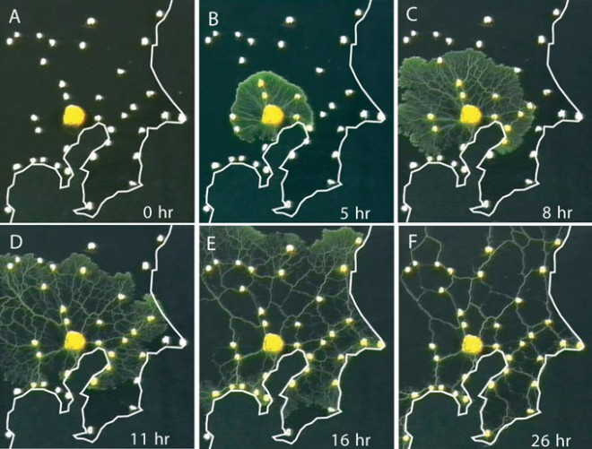

Science/AAAS, http://www.wired.com/2010/01/slime-mold-grows-network-just-like-tokyo-rail-system/

Slime mould is an example of another organism that has been used to explore shortest-path algorithms. Fig () shows slime mould growing to reveal efficient transport routes between significant locations around Tokyo.

Honey bees themselves have come under significant stu.. the travelling salesman problem (a common problem for which significant financial interest exists for finding an effective algorithm).[18] A group at Rothamsted Research recently conducted an experiment to determine what rules bees are using to narrow down solutions effectively as they move from flower to flower. The results were published in 2012.[19] While it was found that bees do not always find the most efficient solution, they do employ an effective heuristic approach to home in on a good enough solution, quickly.

Unsurprisingly the development and optimization of computer algorithms is a significant enterprise, with ramification that reach into all areas of society. While the design and structure of modern computer algorithms is within the realm of human comprehension and ability, the speed and effectiveness with which such algorithms are capable of solving hugely complex problems certainly is not.[20] This is a field that is anticipated to have an increasingly dramatic societal influence, and we therefore deem this to be a highly relevant and appropriate topic.



https://en.wikipedia.org/wiki/Swarm_behaviour#/media/File:Auklet_flock_Shumagins_1986.jpg

Equally important to the success of our game, and its ability to inspire, is that swarm structures are often enthralling to observe; the flocking behavior of birds (see fig()), shoaling fish, or foraging ants. Our hopes are that swarm structures will be equally entertaining to manipulate and design.

### Currently on the Market 2.3.2

In order to effectively focus the player’s attention on the logic and structure of their algorithm, we have decided to move away from text based programming systems. For absolute beginners these low error tolerance systems are unlikely to provide the level of “forgiveness” recommended by our ICT contact at Bristol Grammar School. In relation to this point, the head of ICT introduced us to Scratch (MIT’s visual programming language) and explained that its user-friendly, graphical programming approach is popular with pupils at the school.

This section will analyse relevant games and technologies, such as Scratch, in order to identify areas that we should focus on in the development of our game should to achieve a level of differentiation.

### Scratch 2.3.2a

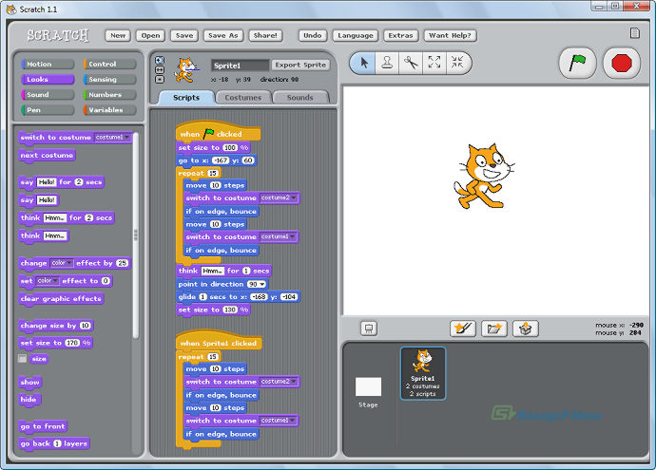

"Scratch is developed by the Lifelong Kindergarten Group at the MIT Media Lab. See http://scratch.mit.edu."

Scratch (first launched in 2003)[21] allows users to easily manipulate sprites using a drag and drop, block based programming language. Sprites are first selected using the mouse and instructions for that sprite are then issued by dragging and arranging code blocks in the editing pane. The language is very popular in educational contexts because of its easy-to-use, intuitive interface. Additionally Scratch’s remix feature allows users to build on and learning from the projects that have already been created by other users.

The scratch editor is sufficiently flexible to allow users to create sprites with simple AIs that are able to respond to changing contexts and actions (requiring a large number of if-else statements). Such scripts are typically very long and tend to be complicated for users to understand. As mentioned on the website this “makes remixing a problem. Because of all this, most AI projects have no improvements, causing the AI to remain glitchy.”[22]

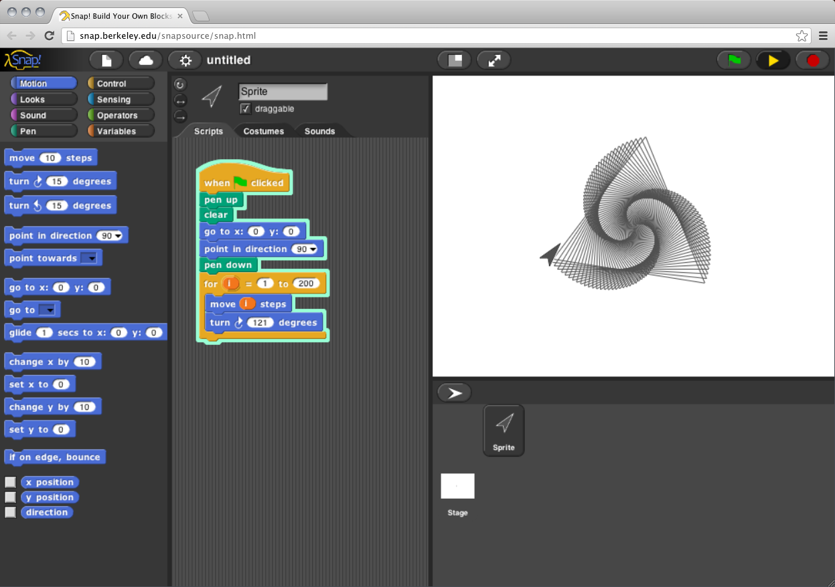

<http://snap.berkeley.edu/run>

Snap! is developed by Jens Mönig with the help of Brian Harvey and an ever-expanding team of Scratchers. It is sponsored by the University of California, Berkeley, with support from the National Science Foundation and the MioSoft Corporation.

A particular technique used by Scratch (and other similar software such as Snap, a scratch derivative) to make flow control structures easier to recognize and follow, is to highlight the edges of affected blocks, and nested groups of blocks, with the same colour. These languages are multipurpose, affording the user flexibility to lots of different things. In our case, the intention will be to specialise in facilitating potentially convoluted flow control structures. This will be necessary for the construction of algorithms that are sufficiently flexible to deal with changing game contexts.

### Educational Coding Games 2.3.2b

Similar visual, educational programming languages to Scratch include Snap[23] (a Scratch derivative launched in 2009), Kodu[24] (2009), and Alice[25] (1998). These all share similar features and are designed to allow individuals to create their own software, games or animations (rather than acting as self-contained or well-defined games themselves).

The majority of games based on visual programming languages that we have come across are aimed at 5-9 year olds. Such games tend to be relatively static puzzle games where instructions are relayed, command by command, to manipulate the state of a specific puzzle. These include lightBot,[26] Kodable,[27] Robozzle.[28] CargoBot[29] (2012) is a game that markets itself for all ages but follows the same relatively static logic of game play. ‘Code Warriors: Hakitzu Battles’[30] (2013) is a related game, aimed at ages 9+, but it is based on combat as opposed to puzzle problems. Players issue commands using a set of functions. The commands are text based (requiring exact syntax) although the same sequential, command by command, move by move approach of the previous games is used, with instructions tailored to a relatively static context.

These systems appear to leave little room for programming condition-based autonomy (to deal effectively with changing contexts in the game). This is intended to be a key feature in our game, although it will require a well-designed algorithm editor/visualiser, as mentioned in the previous section.

### Swarm Manipulation 2.3.2c

Aside from the educational focus of our game, a primary feature will be the ability to design and manipulate the behaviour of a swarm. There are a few freely available games on the market that allow players to manipulate swarm behaviour, in order to achieve certain goals. Swarm Control (2012, by Armour Games)[31] requires the player to protect a bee-hive by instructing a swarm of bees to attack approaching bears. This is instruction is issued by the player conventionally, using a click and swipe actions with the mouse. The game therefore differs to our concept in terms of the mode of player-swarm interaction, and consequently, the complexity of instructions that can be issued.

Another similarly named game, SwarmControl (a 2013 research project by Aron Becker and Chris Ertel)[32] builds on this functionality, giving the player an option to globally or locally attract or repel particles in order to solve a range of different challenges and puzzles (such as rounding up other objects and moving through mazes). Similarly to the previous game, instructions are issued conventionally (using the mouse) and the complexity of instructions are limited.

Other approaches to manipulating swarms tend to present in the form of simulators as opposed to well-defined games. These allow a greater variety of instructions that can be issued to a swarm, using sliding bars or value inputs to alter variables that describe the behavioural rules.

Boid[33] (2009) is an example of one of these systems. While the user is able to alter the actual algorithm that controls the swarm, this manipulation is limited to numeric variables rather than the insertion of new rules or the definition of Boolean conditions. While more sophisticated simulators than Boid will certainly exit, in our search we have not come across any that provide the level of swarm control, in the form of a game, that we intend on providing our players.

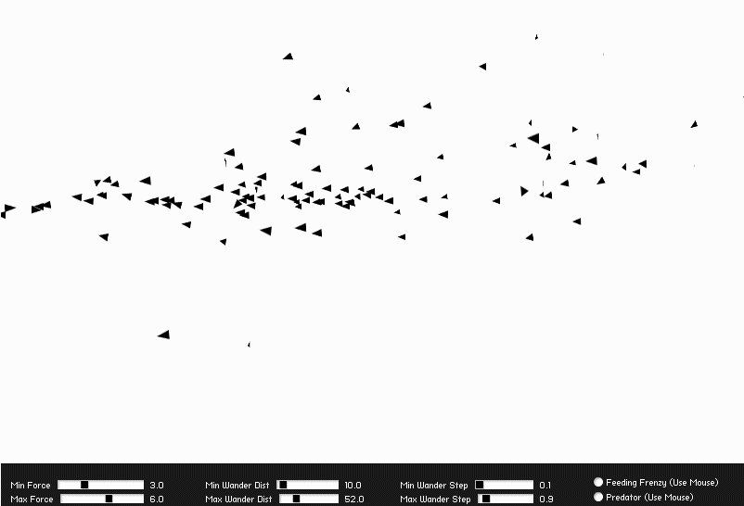

Boid, http://blog.soulwire.co.uk/laboratory/flash/as3-flocking-steering-behaviors

There appears to be a gap in the market for a game that provides an educational coding experience, while providing appropriate control over swarm behavior.

## Final Concept 2.4

The player’s objective in Code A Colony is to design and build a sufficiently complex algorithm to allow their colony to survive for as many years as possible. This will require the bees to explore, to discover and collect resources (enough to brave the winter), and to communicate information to other bees, while also fending off enemies and responding to environmental threats such as rain and snow.

The ubiquity and real-world impact of problem solving algorithms, along with their potential definition by relatively simple rules, makes this an appealing educational topic. Our intention is to develop a system to educate and inspire school children about the underlying mechanism of problem-solving algorithms, and to inspire the next generation of computer scientists and engineers to design and discover the world shaping algorithms of the future.

### Unique Selling Points 2.4.1

In response to our market research, we have formulated a series of features that we intend on emphasizing as unique selling points of our concept. As a means of differentiating ourselves from other educational coding games, our system will:

* Facilitate the construction of complex conditional algorithms (built from simple elements) that are capable of effectively driving autonomous actions in different contexts. The player will spend their time programming decision-making structures rather than defining a static sequence of behaviours for very specific context.
* Provide a block based programming interface that facilitates intuitive comprehension of nested/convoluted flow control structures, so that flexible and dynamic algorithms can be created to drive autonomous behaviour. We will taking some inspiration from Scratch’s drag and drop system, though this is acknowledged to have limited scope for programming autonomous behaviour in an easy-to-read, digestible manner.
* Provide the player with significant control over a colony of bees, allowing them to experiment flexibly with different swarm behaviours and to observe the results of their design at both a local and global scale (close-up view and map view).

# Requirement Specification 3.0

## Introduction 3.1

The Software Requirement Specification (SRS) which follows, is designed to detail how our project is to be implemented, with reference to the scope and purpose of the software, and how that lines up with the requirements of first, the team, and second, the client – and concordantly the target Audience they seek the serve.

## Overview 3.2

Our vision for the game is a system by which a user can control the movement of a swarm of bees using block-based programming. In line with our market research [section 1.4.1], the world is intended to be explorable, non-static, interactive, and open. By the same token, we aim to deliver attractive graphics of a cartoon nature, and an immersive and progressing story with measures of success enabling players to compete with one another. And as advised by the teacher we spoke with, the game should in its nature be forgiving, responsive, and deep.

## Product Components 3.3

The system proposed to address the requirements will have features familiar to users as those of a game: an opening title screen; ongoing sound tracks; informative sound effects; a heads-up display (HUD); a navigable world-map with terrain features; moving characters in the guises of protagonist, adversary, and benefactor; timed events; and interactive objects.

### Opening title screen 3.3.1

As the first view of our product, it is necessary for the title screen to entice users to play the game by showcasing its story and gameplay in a lively manner. It should also accommodate buttons of different utility: at a minimum, a button to start the game, and another to explain it.

### Audio 3.3.2

While audio was not ranked exceptionally high as a valued factor in our market research, we feel it is integral to setting an immersive story (through soundtracks), and providing feedback for actions (through sound effects), which is a key factor in game responsiveness. Audio can also provide an element of humour to make the game more engaging.

### HUD 3.3.3

The HUD is crucial for co-ordinating the movement and status of the hive and is thus the main facilitator of interaction with the game. We specify, as a minimum, the necessity to be able to: keep track of resources; make purchases with those resources; display announcements of timed events; keep track of time remaining until story events; mute audio; view the whole world map in miniature; and above all, program the hive.

### World and terrain 3.3.4

The world should be: large and unbounded enough to be explored freely (an ‘open world’); procedurally generated to increase replayability (giving the game depth); reflective of the story (ie. including grass, flowers, and trees) to aid immersion; and visually attractive (to satisfy the value placed on graphics). The popularity of non-static terrain as a feature also inspires a need for resources such as flowers to deplenish and replenish, and non-interactive scenery like trees and grass to change in appearance over time.

### Characters 3.3.5

Characters are integral to telling stories and immersing through their capacity for humour. By preparing a protagonist (the bee), an adversary (a spider), and a benefactor (“Garry the Ice-cream Man”), we can also achieve a greater level of depth through their interactions.

### Timed Events 3.3.6

We can increase the depth of the game by introducing characters into play through timed events (the adversary and benefactor). Periodic weather effects impacting on the protagonists could serve this purpose. Visible changes in season, culminating in a winter by which time the protagonists must have sought shelter, would also provide a solid framework for a story.

### Interactive objects 3.3.7

The responsiveness of the game depends on interactivity, which, beyond the ability to program how the protagonist interacts with objects, can be provided through an ability to track moving objects by clicking on them.

## Use Characteristics 3.4

The fundamental characteristics of our central target audience are as follows:

* They are Key Stage 3 Learners (between ages 11 and 14).
* They have varying degrees of previous experience in programming.
* They are competent in more general purpose usage of computers.
* They are of mixed genders.

Post-Note:

Whilst these characteristics represent the core target audience, as the product enters its alpha stage of development (with a working framework for all systems, and more-or-less feature completeness) we feel the appeal of Code A Colony may have become somewhat broader, encompassing slightly older and indeed even younger students. This is a facet of its depth combined with its simplicity; more practiced, older students may still take something away from playing the game, while those younger and completely new to coding will quickly be able to pick up the basics of the game, and progress from there.

## Dependencies 3.5

The code will be developed from day one on several different platforms owned by the coding team: Windows 32-bit and 64-bit; Ubuntu 64-bit (as compatible with the university’s lab workstations); and Mac OS X 64-bit. Builds for any of these platforms can be produced by running their respective makefiles (or cmakelists file, in the case of Mac OS development). Internet access is not required in-game. We will make use of graphics acceleration, so OpenGL may need to be installed by the user.

Trackpad support will vary based on trackpad driver (right-click-dragging is widely supported on Microsoft Windows, but not on an Apple Macbook Pro), and stylus/touch support will vary in the same respect based on driver and right-click behaviour setup. Development for mobile systems would be possible (and attractive, given the ubiquity of mobile devices among our target market), although we lack access to suitable development hardware on which to collaborate, so provisionally can’t support them.

## Constraints 3.6

### Time 3.6.1

From the outset, the team is very conscious that our main constraint will inevitably be time. Whilst initial research and conceptual design started in early October, the development cycle will only really begin in earnest come November, leaving us approximately three months to go from writing the first line of code, to exhibition of a final demo.

### Skillset 3.6.2

It is clear that another constraint, tied inextricably to the first, will be that the team is still only now beginning to get to grips with the central technologies the game is to utilize, namely the programming language C, in concert with the library SDL and other subcomponents thereof. We expect this to make the already problematic time constraint all the more challenging to work within; early development will likely be hampered and stop-start as we collectively struggled to familiarize ourselves with the tools for execution of our ambitious designs. Fortunately, we have within our team a wide range of abilities in graphic, video, and audio design going in, so work in those areas should be more manageable.

### Fair Use and Copyright 3.6.3

Whilst we expect at least initially to use placeholder art and sound from “the internet”, we will ultimately need to create our own assets for the project in order to remain within legal constraints. Again this will likely be a time-consuming element of production.

### Divided Focus 3.6.4

While we hope to be able to dedicate ourselves to the product’s development, we appreciate that we there will be periods where the project will be only a secondary priority, as we switch our focus to other parts of the grueling Computer Science Programme at the University of Bristol at various points between now and the project deadline. The extent of this is difficult to predict, as we cannot guess at how taxing other units will become as time progresses.

## Quality Assurance 3.7

### Suitability 3.7.1

The prototype must conform to the requirements of our client – teaching or enthusing youths about computer science. First, we will have to remain mindful of our goals, keeping the purpose in the forefront as our project is moulded. Second, we will need to conduct user-testing and seek informative feedback from our target audience to ensure we are on target.

### Efficiency 3.7.2

The prototype must not be excessively demanding. Whilst our project could certainly become a behemoth, dominating system resources due to its very nature – seeking to emulate and control complex swarm behaviour – we will make every effort to keep computation minimal wherever possible. Our metrics for this will be framerates, responsiveness, and simple system monitoring utilities such as *task manager* and *GPU-z[34]*.

### http://www.giga.de/wp-content/gallery/gpu-z_1/gpu-z-1.jpg?PageSpeed=off&PageSpeedFilters=-resize_images,-resize_rendered_image_dimensionsFlexibility 3.7.3

Figure 3.7-1GPU-Z monitoring of GPU sensors.

The prototype needs to be developed in a malleable manner, such that we can adapt the product as we receive feedback and tweak the direction of the product from time to time. In real terms a large part of this will be in the modularity of the title, and making sure dependencies between said modules are manageable. If changing one module a little, entirely breaks the others we’ll have failed to some extent in this regard.

### Security 3.7.4

We do not expect security to become a concern for our program which will be run entirely locally.

### Maintainability 3.7.5

Once we have delivered the product, we do not expect to be maintaining it, but none-the-less, good coding practice is to endeavour to make the code accessible to new eyes, unfamiliar with the project. To this end we will develop and be consistent to a team style-guide. This will include how we name variables, as well as where and when to include comments, and at what level of detail.

### Portability 3.7.6

As we all have different native operating environments in which we will be developing (Linux, Macintosh, and Windows) it will be important from the off that we ensure our code is easily portable between platforms. The metric for judging this will be simply whether or not we can consistently compile and run it on these different OSes.

### Stability 3.7.7

The prototype should be stable. This means it should crash rarely if ever, and certainly any reproducible bugs should be fixed at the earliest opportunity. Testing should as far as possible explore all possibilities for the ways a user might interact with our product, and if we can take the software to its very limits without breaking it, we can be satisfied in its stability.

### Usability 3.7.8

The prototype must be accessible to users. It would evidently be pointless to build a flawless swarm emulator, with complex and complete user control of the underlying AI if the user is then unable to engage with a cryptic user interface. Ergo usability must remain at the forefront of the team’s consciousness throughout design and implementation. This will be another area where user-testing a feedback will be crucial to success.

## Use Cases 3.8

### Program operation 3.8.1

The player, a student, will open the program to be faced with the title screen, whereupon they can choose with a button press whether to view a tutorial or start the game itself. Viewing the tutorial displays an explanatory image, which can be closed once satisfied. By choosing rather to start the game, the game loop will begin. The game loop can be paused at any point with the input of a pause key. At any point throughout the program, the user may mute or unmute its default-on audio by clicking the (un)mute button, or close it altogether by cllicking the ‘X’ button in the corner of the program’s window. [reference the figure]

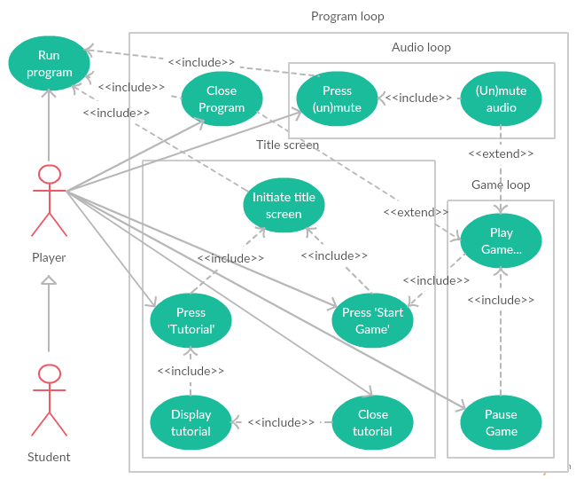

### Block-based programming operation 3.8.2

Once the player has initiated the game loop, they may program the AI of the protagonists in the ‘B++’ language: First, by clicking a button labelled ‘B++’ to open the B++ menu, they may operate the B++ programming environment. Therein, codeblocks selected (with a click) from a scrollable sidebar may be created, moved into position and linked together with mouse-drag operations, or input with parameters using mouse-clicks. Once a program has been assembled, the player may run its code, updating the protagonists’ AI, by clicking the ‘run code’ button (indicated with a ‘play’ symbol). Thereafter, the player may click the ‘stop code’ button (indicated with a ‘stop’ symbol) from within the B++ menu to recall protagonists to the hive and reset their AI to the default idling mode until an AI code is run again. At any time whilst the B++ menu is open, it may be closed by clicking the ‘X’ button in the menu’s top-right corner. [reference the figure]

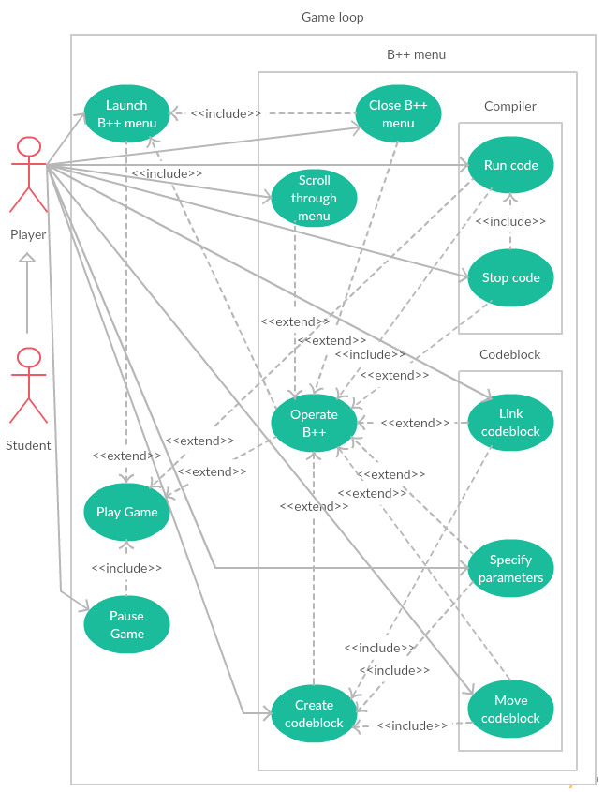

### Gameplay 3.8.3

Having initiated the game loop, the player may play the game. The primary characters, the bees, receive their AI from the (player-influenced) B++ system. These bees move and respond to their environment based on their AI. The environment includes: terrain (trees and grass); season; the hive; weather; characters (such as the spider adversary and the Ice Cream Man benefactor); and resources (flowers, and ice creams liberated from the Ice Cream Man). Existence of the bees depends on their interaction with the season and the spider (they die in winter without cover, and may die to spider attacks), and on whether they have yet been purchased, though some will be provided at the game start. Purchases are made by clicking the hive cell icons, an action which depends on having gathered sufficient honey stocks with bees beforehand.

All environment objects become spawned with the start of the game loop unless their existence is explicitly affected by the progression of time (as is that of the two characters). Time progression furthermore influences in some way all environmental features save for terrain (which takes appearance update cues from the season) and the hive: the season updates, the weather changes, new flowers spawn to replace old ones, and the entering on-screen of both the Ice Cream Man and the spider. The spider furthermore changes direction with time, while the Ice Cream Man’s movements are influenced purely by the weather. The continued existence of the Ice Cream Man is not influenced by any factor, although that of the spider is influenced by bee attacks. Of note, however, bee attacks may liberate ice creams from the Ice Cream Man.

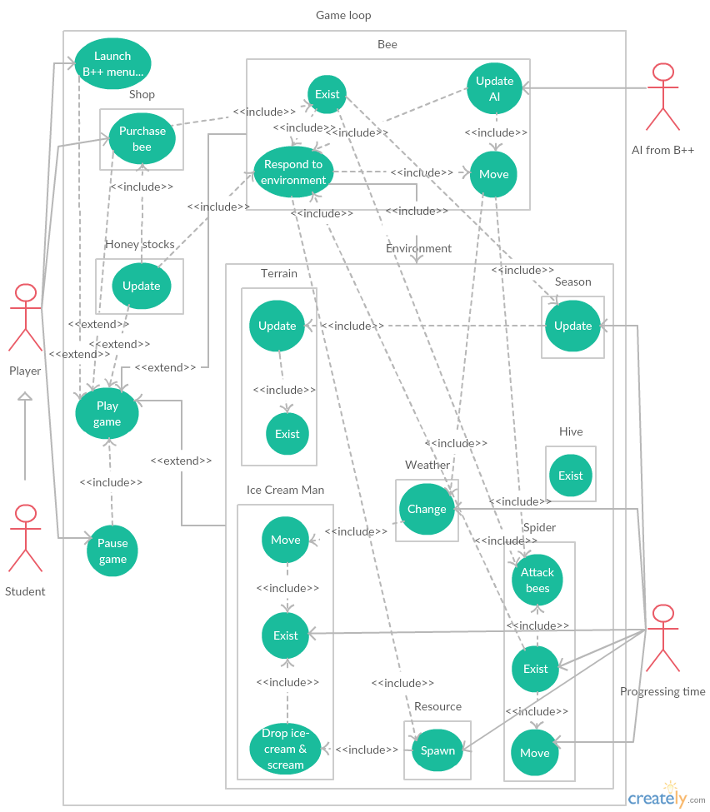

# Design Implementation 4.0

## Module Design 4.1

Linear dependency Structure

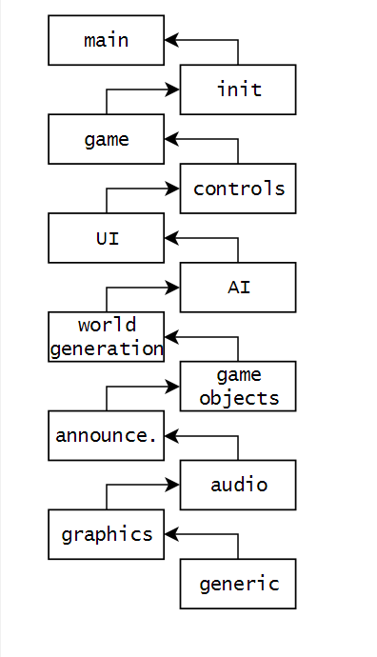

## Systems Architecture 4.2

The graph below shows the proportion of code that is contained in each module.

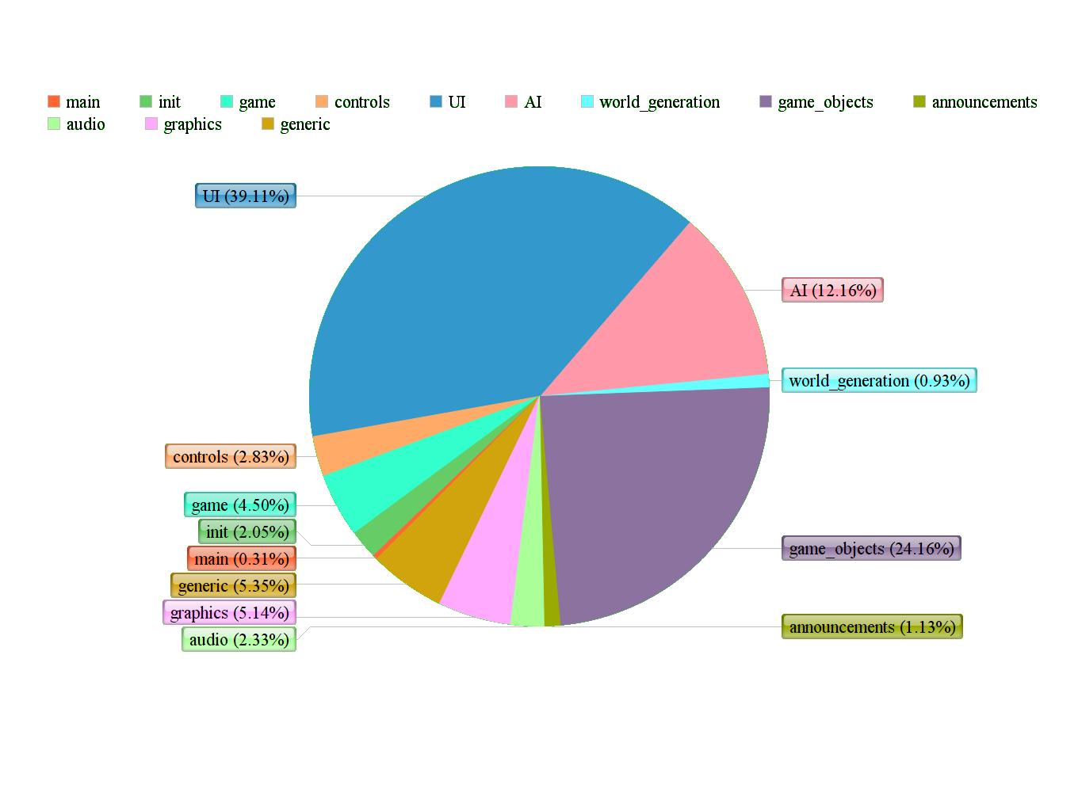

## Graphics 4.3

Being a core interest implicated in our market research, great attention was dedicated to the graphics module of the game. Graphics usages included: the splash screen; the game world; the objects within the game; and the user interface. Each of these graphics applications went through a design process involving input from the whole group.

### Opening title screen 4.3.1

Concept sketches were produced and put up for team input. One design was favoured and further developed into a colour sketch, which was then translated into a digital painting; details like scenery were developed upon with input from group members.

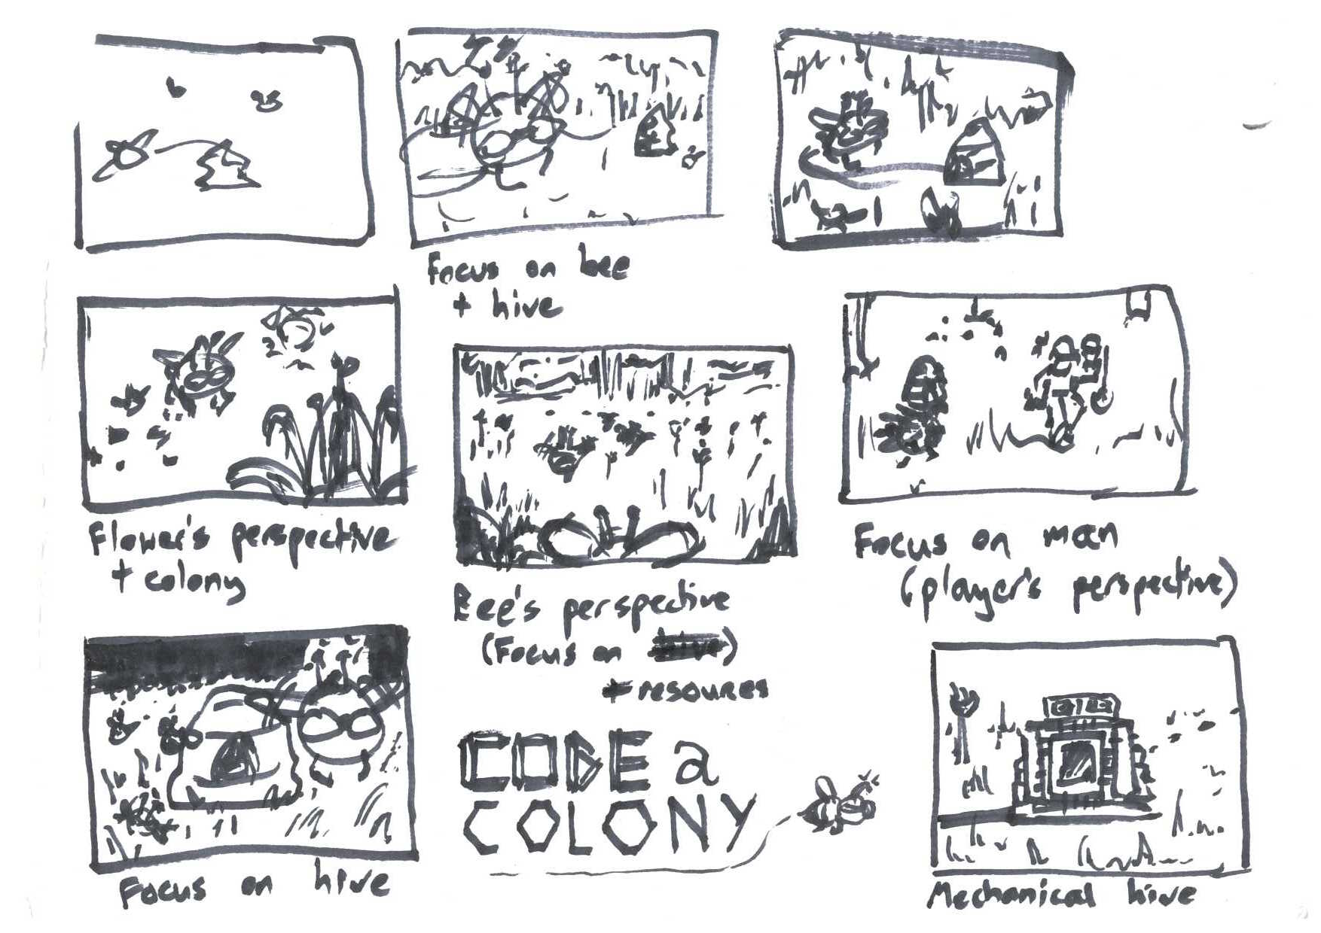

[Title screen concepts]

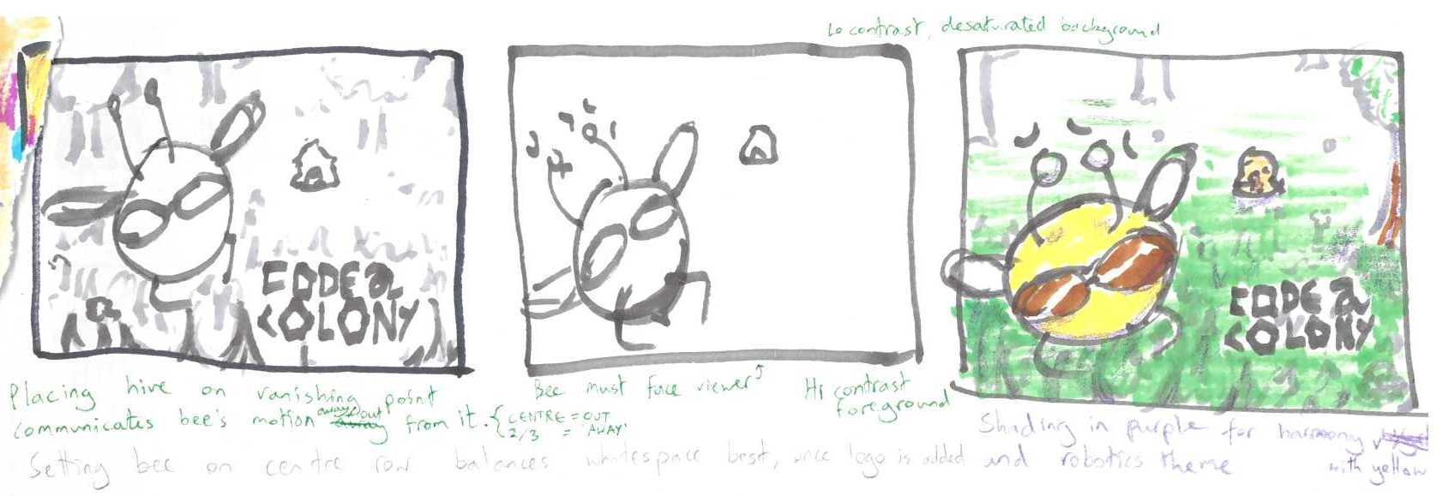

[Title screen further development]

 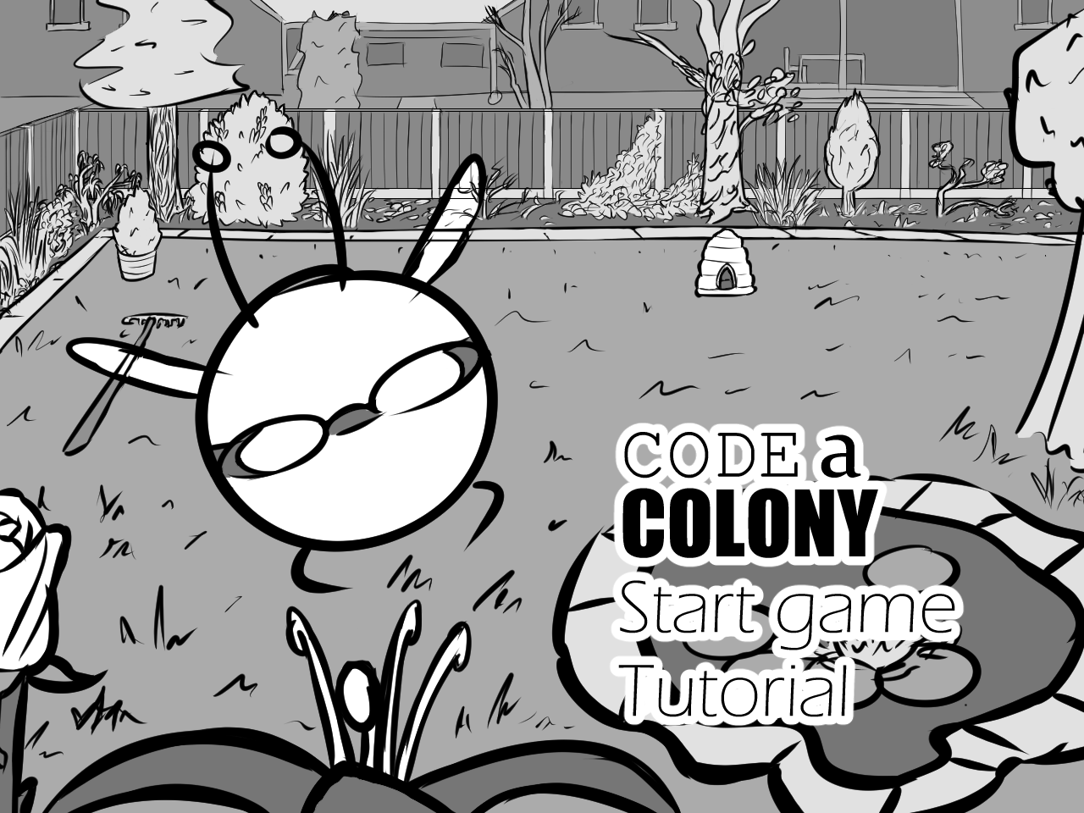

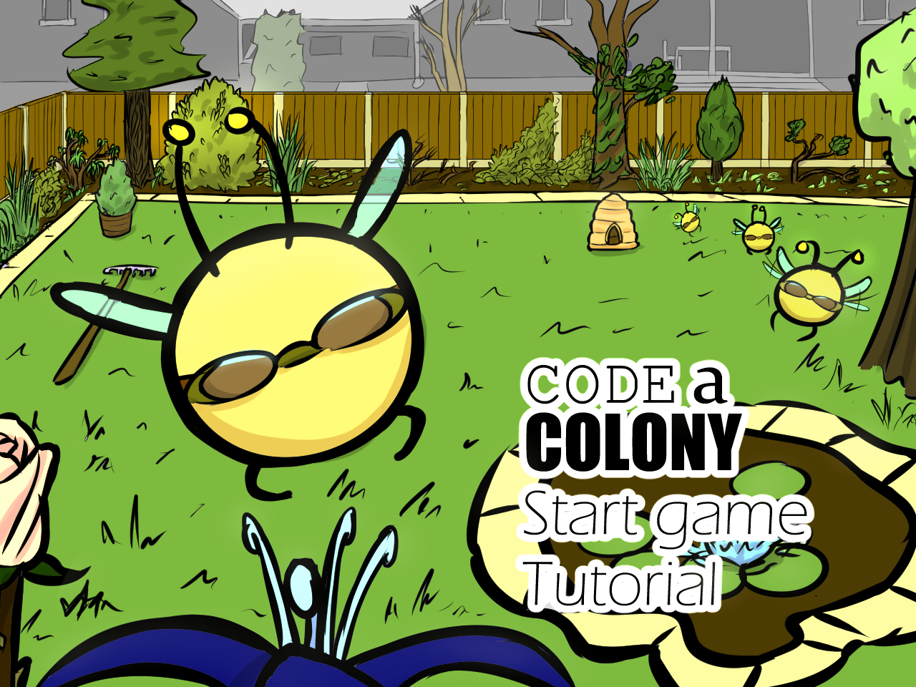

[Title screen digital development]

### Game world 4.3.2

The game world consisted of a large grass background stretching beyond the extents of the viewing window which could necessarily be scrolled along. Initially, a green rectangle was used, but this was later replaced with a repeating drawn grass texture. This original grass texture unfortunately didn’t tile well, so the final grass used in the game is a placeholder: a stock image sourced from Google Images.

### Game objects 4.3.3

Placeholder stock images sourced from Google Images were again exploited for flowers, the spider, and ‘Garry, the ice cream man’. The hive image was drawn without considerable development, while the stars of the game – the bees – were developed through a series of digital sketches put up to a vote, culminating in design ‘D’ being chosen. The accessory flight goggles indicating that the bee was part of the initially planned ‘scout class’ remain in use for all bees, as a class system was ultimately never implemented in the final product. The decision to leave the goggles on display was simply that we felt their mere presence added character to the bee.



[Bee development]

### User interface 4.3.4

Design of the user interface was delegated to one member in the group, then implemented by another. This initial implementation suffered from an illegible font, lack of colour hierarchy and co-ordination, and unlabelled buttons. Incremental changes to the interface (based on in-practice navigability and user-friendliness) were gradually made with input from everyone, resulting in a compact and responsive interface that was intuitive enough for the target users to operate when finally exposed to the product [see section ___ ].

## Audio Design 4.5

For audio creation we utilized two approaches. For most sound we used tools to create all new sounds for the project. The exception is In the case of one particular sound which we cut from the popular TV series *“Game of Thrones”* as a deliberate comedic Easter Egg[35].

The first audio we set out to implement was the music – a decision we latterly regretted as it began to haunt our dreams. Initially we began this process using the open source tool Audacity (figure 4.5-1), but due to the stylistic choices we were making – with a retro 16-bit, Amiga-like feel, to complement the cartoon graphical style – it became clear the software wouldn’t suffice. Instead we moved to Cakewalk’s Sonar X3 (figure 4.5-2), a professional suite with stronger MIDI support, and more nuanced and powerful post production capabilities. The tracks that play after the splash screen is dismissed are all designed as an homage to early 90s games, which would often cover, and slightly jazz up, popular hits[36]. Though these custom-recorded tunes can repeat with enormous frequency, even during just a single play-through given their small number, they are catchy, and enjoyable, and the melodies sneakily keep the game in your consciousness even hours later. The three songs shipping with the game are reimagined versions of “*Ain’t No Sunshine[37]*”, “*Summertime[38]*”, & *“Black Horse & A Cherry Tree[39]”.*

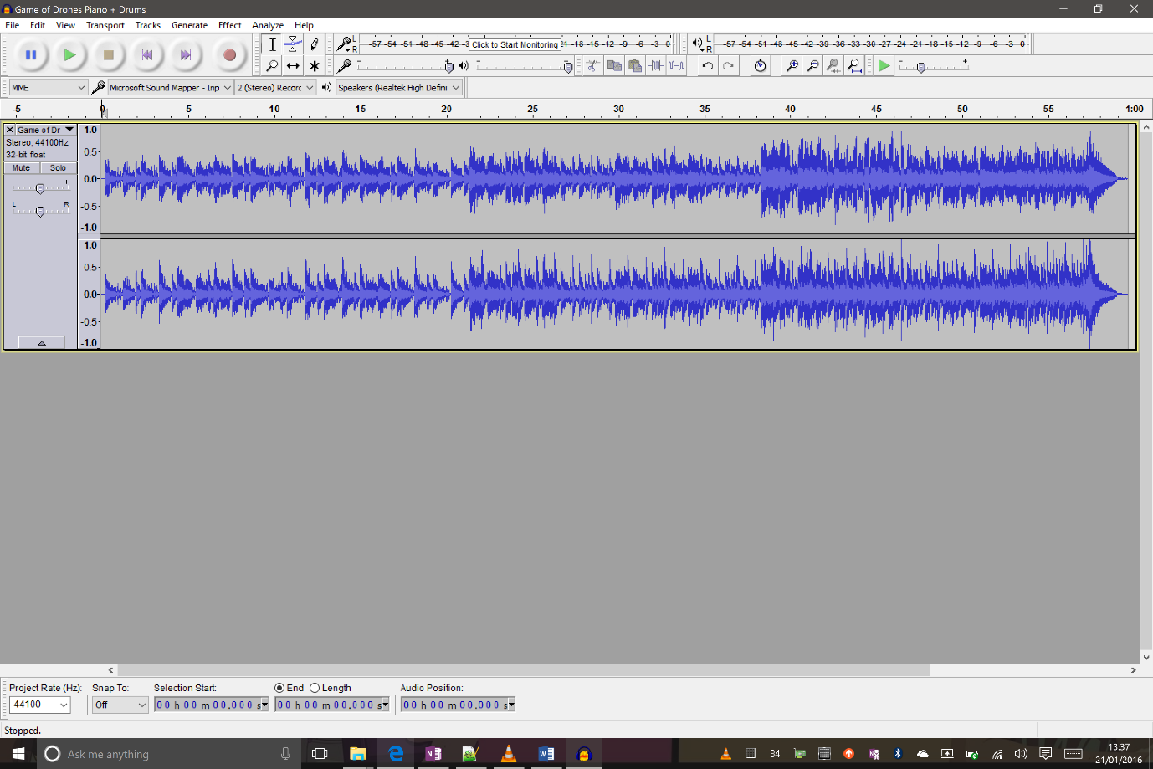

Figure 4.5-1: Audacity

The theme song which plays upon initial game launch is another homage, in equal parts, to *“the Frog Song[40]”*, and again to Game of Thrones, owing to an early jocular working-title of the game: *“Game of Drones”*. Whilst the other tracks required principally the use of a midi-keyboard and drum-kit, the idea of the theme was to mimic the hum of a swarm. For this we simply layered ourselves ‘buzzing’ the theme, and layered various recordings on top of each other to give the sound a depth to simulate the swarm.

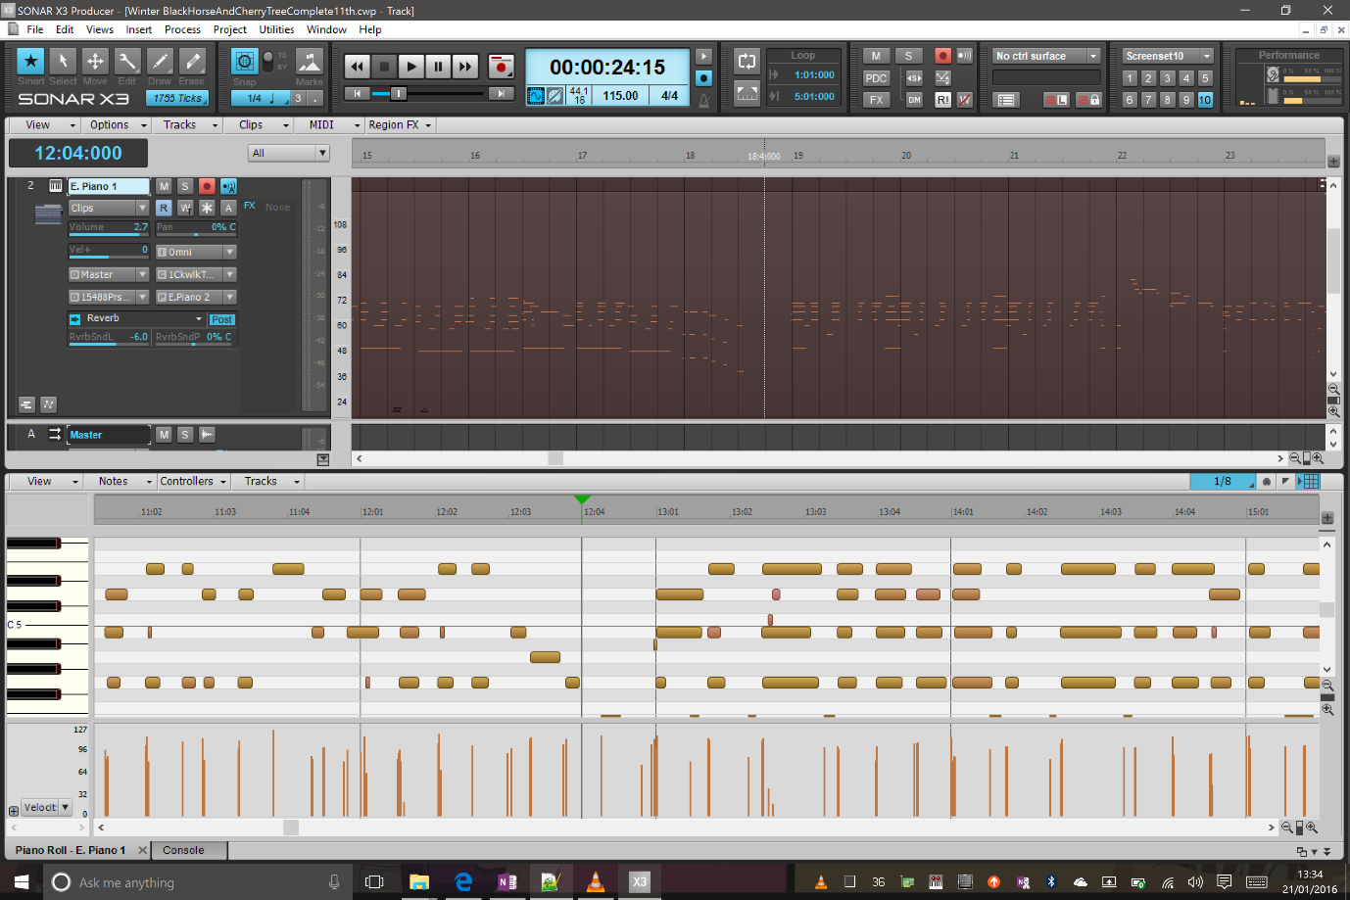

Figure 4.5-2: Cakewalk Sonar X3

The remaining sound effects integrated include a midi-piano-generated chirp, played when the user increments his honey counter (score) by 50, a rain sound effect for when it is raining, taken from SoundBible (a royalty free sound bites project at [*http://soundbible.com/royalty-free-sounds-1.html*](http://soundbible.com/royalty-free-sounds-1.html) ) and a scream for when the Ice-Cream-carrying-victim is stung. For this last sound effect, we asked (with the teacher’s permission) if we could get member of the class who were part of our focus group to record a scream, with the promise that we would integrate the best one into the game.

## Core Features 4.6

## Unit Testing 4.7

We have adopted the unit testing framework check to perform testing. Check is from the webpage (http://libcheck.github.io/check/).

The scope of testing included (i) a full scope testing for all functions in generic.c and control.c, and (ii) limited testing on selected functions in other .c files.

To test a function which returns an output (could be a predefined type or a struct), we would check if the output of the function match our expected value or not. If it matches our expected value, it passes the test. Otherwise, the test is failed and we need to investigate the reason of failing the test.

Some functions are void functions thus not returning any value. In order to test these functions, we would investigate the changes carried out by these functions. The testing method is to check the expected value of certain variables after performing these functions.

Some functions involved inputs and/or outputs SDL type of variables. Thus, we need to initialize these variables properly before testing these functions. For function output to the screen directly, we would need to test them using methods similar to testing void functions.

## User Testing 4.8

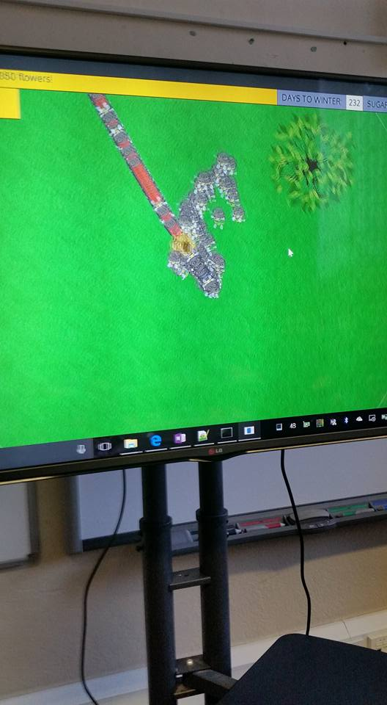

On Thursday 14th January we returned to British Grammar School to show the pupils are prototype and allow them to play.

We were able to spot several bugs that we had not noticed before, in addition to improve game play parameters (the children found that the “Days To Winter” count down moved too quickly).

The biggest bug that was found related to the ice-cream carrying character (Garry). Under certain circumstances, Garry could be stung repeatedly and an endless stream of dropped ice creams would be created (as opposed to just one, as intended). The image to the left shows a long stream of bees carrying red coloured ice-cream back to the hive (and then going after Garry for more).

We have since fixed this bug, and created a list of all of the feedback that we have been given. We have been able to address some of this feedback already, while some will guide us during future development.

Some pupils decided to write their comments down on stickynotes (shown in the following image).

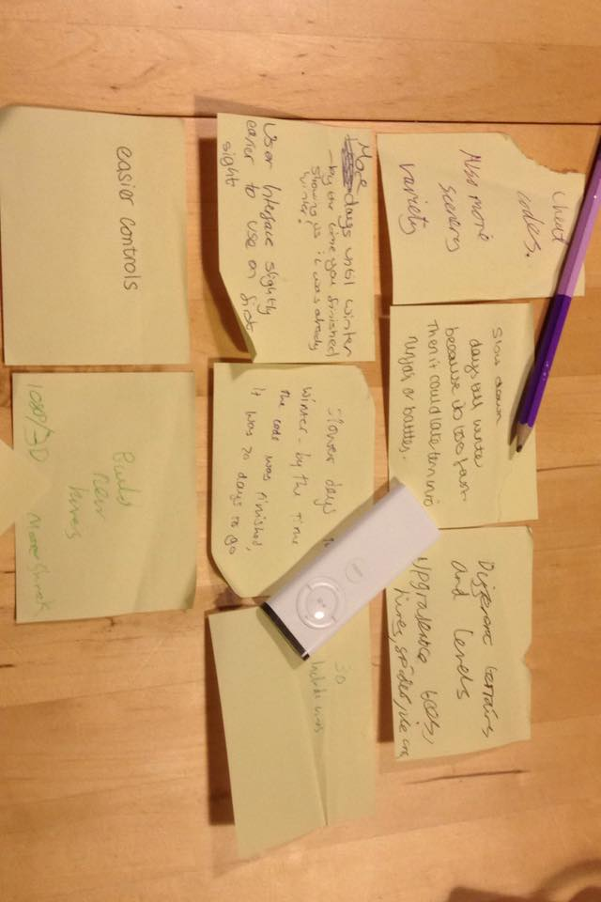

|  |  |
| --- | --- |
| Add more variety to scenery / different terrain |  |
| Slow down “Days To Winter” counter | done |
| More intuitive user interface / easier controls | In progress |
| Ability to build new hives / compete with other hives |  |
| More sound effects / theme tunes | In progress |
| Option for different skins / game themes (space, underwater etc.) |  |
| Make function names less confusing | done |
|  |  |

## Tools 4.9

### Collaboration 4.9.1

For coding, we used GitHub (see section 4.8.4) as a version repository through which we could generate branches from a master version of the code to then be edited and later pushed (and merged when necessary) as a newer version. Despite its steep learning curve, we all came to value the power it offered in enabling multiple people to work with minimal impact on each other and its capacity to rewind any ill-made edits.

For creating presentations, we used Google’s Cloud-based office suite, allowing simultaneous, instantly pushed and pulled edits. While limited in capabilities, it proved a very streamlined tool for collaboration.

For this report writeup, we hosted the report on Microsoft Onedrive, allowing simultaneous, albeit evidently not instant, edits (which caused some grief and thus removed it as a candidate for future collaborative work) using Microsoft Word.

### C 4.9.2

Coded entirely in C, the tools we chose a variety of tools to ease working with the language.

* **SDL2 and associated libraries:** SDL was the graphics library of choice in our Programming in C module, so we were happy when it was specified as the suggested graphics library to be used in this project’s module. It proved to be fairly easy to use once accustomed to, and by compiling the SDL2, SDL_ttf and SDL_mixer libraries for the lab machines, we were able to expand our usable featureset to include text manipulation and audio. However, constantly linking new libraries for each of our development platforms proved burdensome, so incorporation of additional libaries such as SDL_image (for advanced image features like alpha channels and PNG support) had to be abandoned to keep the project moving forward. Licenses: zlib.
* **Unit testing framework:** We chose Check for its very intuitive appearance, and for it being pre-installed on the lab machines. It proved to have a fair featureset (able to divide test-cases into sets of tests and suites, and has ‘forking’ to enable continuing tests despite segfaults, unlike the rival framework CUnit), although the pitifully low amount of documentation meant that we lacked any knowledge of certain desired features such as how to set up mocking for tests. License: LGPL.
* **Debuggers:** Simply those that were ready integrated into our development environments: on Linux and Windows, GDB; and on Mac, LLDB. Licenses: GNU GPL and LLVM, respectively.
* **Memory management:** Where memory leaks and segfaults were of concern, Valgrind was used for being well-known and pre-installed on the lab machines. License: GNU GPL.

### Media 4.9.3

Our team used the tools we were most familiar with: for digital art, Celsys Clip Studio Paint; for image editing, Adobe Photoshop and GIMP 2; for video creation, Microsoft Movie Maker; and for audio, Cakewalk Sonar X3 (and briefly Audacity).

### Version control 4.9.4

We used ‘git’ as a version control system, pushing remotely to GitHub due to having an existing university account for it that could host a private multi-user repository, unlike the public ones we’d generally be limited to with other services, and also due to the advantage of being able to accustomise ourselves with such an industry standard. While the learning curve was steep, it worked well as a version control tool, and we expect the experience would have been largely the same no matter what remote service had been used. Since we were more familiar with git than alternatives such as SVN, we were content with our choice of underlying system too.

Git proved extremely powerful, allowing us to roll back changes when additions by one user, such as integration of the SDL_image library, were found difficult to reproduce on other development platforms. Segfaults beginning to occur for some users but not others also invited the use of git’s ability compare to older versions of the code.

### Prototype Design & Experiments 4.9.5

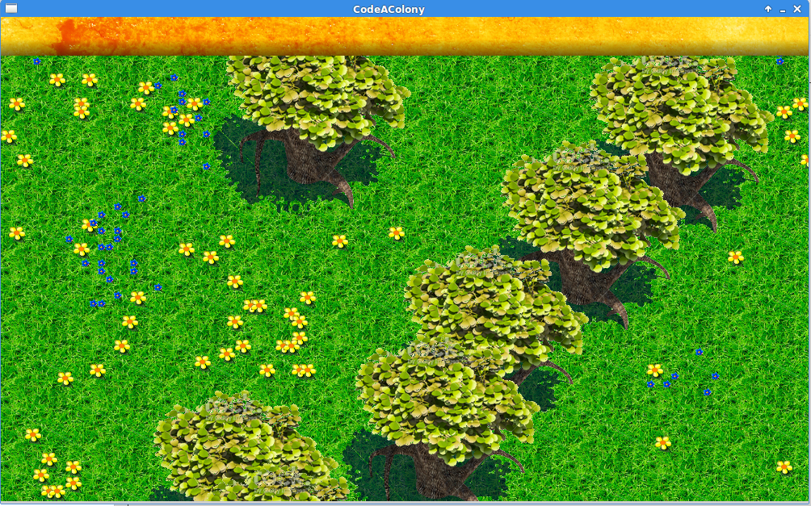

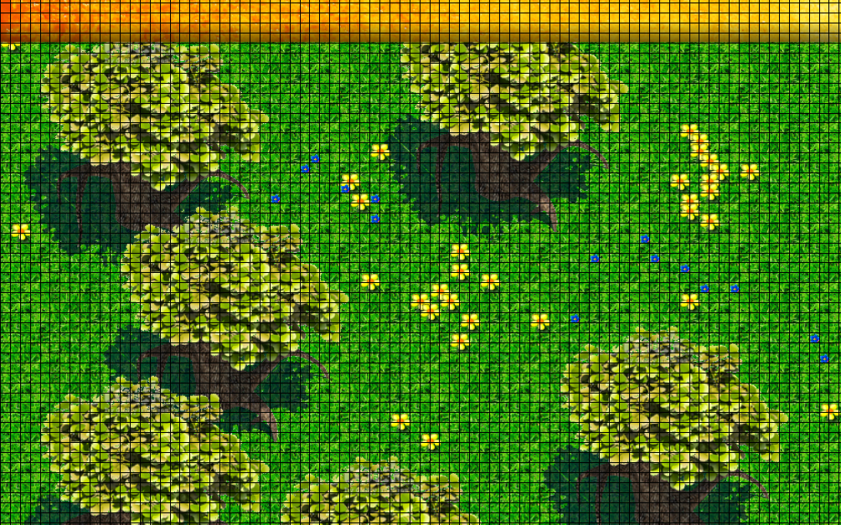

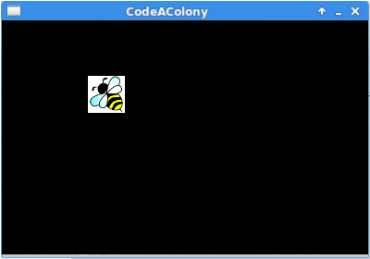

# Project Management 5.0

## 5.1 Introduction

Communication is key in Project Management and plays a vital role in the overall completion and success of the project, therefore all group members exchanged mobile numbers, email addresses, and a Facebook group was created to ensure that communication channels were open at all times.

Our Project Management system incorporated weekly meetings, planning and scheduling of the project, task allocation, a feasibility study and risk analysis.

### 5.1.1 Project Manager

We chose not to appoint one person as Project Manager but instead ensured that each group member worked on every aspect of the project, with weekly meetings to resolve any issues or discuss any problems encountered.

## 5.2 Planning & Scheduling

From the very first meeting, when groups were announced, ideas were pitched with interesting concepts being formed. The group decided to meet frequently over the next couple of weeks to continue pitching ideas and to nail down a few strong concepts.

Once concept ideas were in place, we were able to visit Bristol Grammar School in order to conduct some market research and gather feedback from a small collection of our target audience.

From this data collected we were able to select the best suited concept and progress with building the idea.

### 5.2.1 Planning

Weekly sprints and pair programming sessions played a vital part in completing a successful project. Weekly sprints allowed us to work together as a team, seeking advice when needed, and discussing any issues or problems. Pair programming sessions allowed less experienced members of the team to become involved in more complex areas of coding, understanding what the code meant, how this affected the game and contributing their own pieces of code.

Scrum meetings allowed us to determine where we were at with the project compared to where we wanted to be and assign tasks, implement our own deadlines, and schedule further meetings accordingly.

### 5.2.2 Scheduling

Early on in the project frequent meetings were scheduled to decide on a concrete concept. An all day sprint was also scheduled to ensure that all team members’ personal computers were set up with the necessary programs to work on the project individually.

Regular meetings were held weekly to work on presentations, discuss any issues, and areas of concern if anyone needed help. Regular sprints were where we carried out most of the work on the project, working as a group on individual sections of the project, with all team members available if anyone needed help or advice in any particular area. However we did also work on the project individually which is where the Facebook group played a large role, especially at early hours of the morning when a quick answer was needed.

### 5.2.3 Group Meetings

We conducted regular group meetings to outline the roadmap for the project and assign group members to tasks. At the start of the project, these were weekly, but as specifications and goals became more concrete, short scrums during sprints became the main means by which we gathered to assess the status of the project.

|  |  |  |  |
| --- | --- | --- | --- |
| ***Meeting*** | ***Date*** | ***Purpose*** | ***Conclusion*** |
| *0* | *01/10/15* | *Group formation* | *Assigned team and learned each others’ specialties* |
| *1* | *05/10/15* | *Planning of focus group* | *See lesson plan in appendix 2.1.* |
| *2* | *07/10/15* | *Rehearsal for meeting focus group* | *See produced questionnaire in appendix 2.2.* |
| *3* | *08/10/15* | *Reviewing research findings and preparing first presentation* | *Details, inc. minutes, at* [*https://github.com/Syreniac/verdant-octo-spork/wiki/M3:-discussing-research-findings-and-requirements-for-presentation;-Thu-8th-Oct*](https://github.com/Syreniac/verdant-octo-spork/wiki/M3:-discussing-research-findings-and-requirements-for-presentation;-Thu-8th-Oct) |
| *4* | *15/10/15* | *Rehearsal for first presentation* | *√* |
| *5* | *19/10/15* | *Deciding project vision* | *Defined minimum viable product as “bees that can be programmed to move… placed on a background”.* |
| *6* | *20/10/15* | *Introduction to SDL and preparation of second presentation.* | *√* |
| *7* | *22/10/15* | *Delivery of second presentation and timetabling of sprint* | *√* |
| *8* | *29/10/15* | *Scrum to confirm sprint location* | *Organised sprint at Jamie’s house* |
| *9* | *30/10/15* | *Sprint to set up SDL and MinGW* | *√* |
| *10* | *04/11/15* | *Sprint to make two buttons* | *√* |
| *11* | *05/11/15* | *Sprint (various aims)* | *See extensive commit log for details:* [*https://github.com/Syreniac/verdant-octo-spork/commits/master*](https://github.com/Syreniac/verdant-octo-spork/commits/master) |
| *12* | *09/11/15* | *Sprint to make makefile and pause function* | *√* |
| *13* | *09/11/15* | *Progress review, task allocation and deciding game name* | *Sam: setting up audio; Tony: setting up start menu; Jamie: implementing rotating sprites; Matt & Sarah: GUI. Alex: making tiled, navigable background.*  *Game name decided to be Code A Colony.* |
| *14* | *30/11/15* | *Task allocation* | *Jamie: splash screen; Tony: arrow-heads; Sarah: GUI; Alex: animating bee; Sam: further audio; Matt: linking SDL_ttf* |
| *15+* | *Dec onwards* | *Weekly sprints (various)* | *See extensive commit log for details:* [*https://github.com/Syreniac/verdant-octo-spork/commits/master*](https://github.com/Syreniac/verdant-octo-spork/commits/master) |

[Table of meetings and their conclusions. A ‘tick’ indicates having exactly met the described purpose.]

### 5.2.4 Tools

Throughout this process the group used a number of tools in order to ensure a successful project. These tools included:

1. Pair Programming
2. Sprints
3. Scrum Meetings

1. Pair Programming

Pair programming played a vital role in the implementation process, with varied experience within the group pair programming allowed team members to teach each other based on their area of expertise. At the end of this process we feel as a group that we have all learnt a great deal in areas where we previously had little or no experience. Pair programming also allowed us to avoid mistakes in the code, with one person programming and another team member watching over their shoulder, gave us two sets of eyes to ensure that the code we were implementing was correct.

2. Sprints

Most of our work was carried out during team sprints allowing questions to be asked and solutions to be found as the rest of the group were available to assist.

Team sprints also allowed team members to provide tutorials to other members who needed them, and help set up laptops so that members could work on the project individually.

We prepared all of our presentations in team sprints, allowing everyone to be involved in this process, also allowing us to practice the presentations ensuring a polished, well presented delivery.

3. Scrum Meetings

Scrum meetings allowed the team to gather frequently and discuss the project road map, task allocation and the next sprint. This ensured that time management was being monitored throughout the project and any concerns could be raised in these scrum meetings. They also meant that we could meet frequently between lectures, whilst juggling other commitments and assignments to ensure communication was frequent.

### 5.2.5 Gantt Chart

The first Gantt chart was designed at the very early stages of development so that we could see what tasks needed to be done, and we attempted to implement our own deadlines for task completion. Our lack of experience made this process difficult in knowing how long to allocate for each task.

|  |  |  |  |  |
| --- | --- | --- | --- | --- |
| ***Task*** | ***Start Date*** | ***End Date*** | ***Duration*** | ***Complete*** |
| *Initials Ideas:*  *Come up with 2 – 3 ideas.* | *01/10/15* | *05/10/15* | *5 days* | *Y* |
| *Prepare for focus group meeting.* | *05/10/15* | *07/10/15* | *3 days* | *Y* |
| *Finalize game concept: prepare minimum viable product.* | *08/10/15* | *19/10/15* | *11 days* | *Y* |
| *Prepare presentation: initial ideas.* | *08/10/15* | *15/10/15* | *7 days* | *Y* |
| *Allocate tasks.* | *15/10/15* | *15/10/15* | *1 day* | *Y* |
| *Prepare second presentation.* | *15/10/15* | *22/10/15* | *7 days* | *Y* |
| *Implement background graphics.* | *23/10/15* | *06/11/15* | *14 days* | *Y* |
| *Implement individual graphics: bee, flowers, hive.* | *09/11/15* | *23/11/15* | *14 days* | *Y* |
| *Collision detection.* | *23/10/15* | *06/11/15* | *14 days* | *Y* |
| *Explorable world and mini map.* | *09/11/15* | *23/11/15* | *7 days* | *Y* |
| *Problem solving.* | *09/11/15* | *13/11/15* | *5 days* | *Y* |
| *Block programming.* | *23/11/15* | *07/12/15* | *14 days* | *Y* |
| *Hive view map.* | *24/11/15* | *30/11/15* | *6 days* | *N* |
| *Menu Screen.* | *16/11/15* | *23/11/15* | *7 days* | *Y* |
| *Features: Bear Attack* | *03/12/15* | *10/12/15* | *7 days* | *N* |
| *Honey counter.* | *03/12/15* | *10/12/15* | *7 days* | *Y* |
| *Problem solving.* | *23/11/15* | *09/12/15* | *16 days* | *N* |
| *Features.* | *11/12/15* | *18/12/15* | *7 days* | *N* |
| *Prepare third presentation.* | *03/12/15* | *10/12/15* | *7 days* | *Y* |
| *Prepare final presentation.* | *01/01/16* | *22/01/15* | *22 days* | *Y* |
| *Report.* | *01/10/15* | *25/01/15* | *Duration of project.* | *Y* |

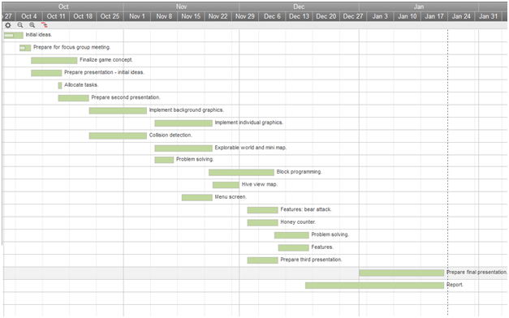 The second Gantt shows an adaptation of the first, early on in the project and highlights our learning experience. We adapted time scales once we realized that tasks would take much longer than anticipated, and were not a simple case of completing the task and moving on to the next. This chart also highlights that we made much more time for learning curves, and problem solving. Certain tasks that existed in the first chart such as the ‘Bear Attack Feature’ have been removed, as we simply did not have time to complete them, and have been put aside for future development.

Other tasks have been added in, such as a mute button, as we only realized (after the sound of buzzing bees haunting our dreams) that this was a vital feature to the game.

|  |  |  |  |  |
| --- | --- | --- | --- | --- |
| ***Task*** | ***Start Date*** | ***End Date*** | ***Duration*** | ***Complete*** |
| *Initials Ideas.*  *– Come up with 2–3 ideas.* | *01/10/15* | *05/10/15* | *5 days* | *Y* |
| *Prepare for focus group meeting.* | *05/10/15* | *07/10/15* | *3 days* | *Y* |
| *Finalize game concept.* | *08/10/15* | *19/10/15* | *12 days* | *Y* |
| *Prepare initial ideas presentation.* | *08/10/15* | *15/10/15* | *8 days* | *Y* |
| *Introduction to SDL.* | *20/10/15* | *20/10/15* | *1 day* | *Y* |
| *Set up SDL/Min GW.* | *30/10/15* | *30/10/15* | *1 day* | *Y* |
| *Familiarize with Github/Min GW.* | *20/10/15* | *30/10/15* | *11 days* | *Y* |
| *Task allocation.* | *09/11/15* | *09/11/15* | *1 day* | *Y* |
| *Create Makefile.* | *09/11/15* | *09/11/15* | *1 day* | *Y* |
| *Create pause button.* | *09/11/15* | *09/11/15* | *1 day* | *Y* |
| *Implement background graphics.* | *09/11/15* | *30/11/15* | *22 days* | *Y* |
| *Implement bee, hive and flower graphics.* | *09/11/15* | *30/11/15* | *22 days* | *Y* |
| *Implement audio.* | *09/11/15* | *30/11/15* | *22 days* | *Y* |
| *Problem solving: better graphics needed.* | *30/11/15* | *30/11/15* | *1 day* | *Y* |
| *Project review, task allocation.* | *30/11/15* | *30/11/15* | *1 day* | *Y* |
| *Implement explorable world.* | *11/11/15* | *30/11/15* | *20 days* | *Y* |
| *Problem solving: explorable world.* | *26/11/15* | *26/11/15* | *1 day* | *Y* |
| *Implement collision detection.* | *11/11/15* | *30/11/15* | *20 days* | *Y* |
| *Create menu screen* | *17/12/15* | *01/01/16* | *16 days* | *Y* |
| *Honey counter.* | *07/12/15* | *07/12/15* | *1 day* | *Y* |
| *Implement features:*  *– Ice cream man.* | *18/12/15* | *20/01/16* | *3 days* | *Y* |
| *Problem solving: collision detection, explorable world.* | *07/12/15* | *07/12/15* | *1 day* | *Y* |
| *Implement block programming* | *07/12/15* | *20/01/15* | *44 days* | *Y* |
| *Font selections.* | *08/01/16* | *08/01/16* | *1 day* | *Y* |
| *Colour selections.* | *08/01/16* | *08/01/16* | *1 day* | *Y* |
| *Implement test cases.* | *11/01/16* | *20/01/16* | *10 days* | *Y* |
| *Problem solving: change from array to linked lists – allow more bees.* | *13/01/16* | *13/01/16* | *1 day* | *Y* |
| *Implement bee tracking.* | *11/01/16* | *20/01/16* | *10 days* | *Y* |
| *Problem solving.* | *08/01/16* | *08/01/16* | *1 day* | *Y* |
| *Mute button.* | *11/01/16* | *11/01/16* | *1 day* | *Y* |
| *Mini map: explorable world.* | *01/01/16* | *20/01/16* | *20 days* | *Y* |
| *Announcements toolbar.* | *08/01/16* | *20/01/16* | *13 days* | *Y* |
| *Final presentation.* | *21/01/16* | *21/01/16* | *1 day* | *Y* |

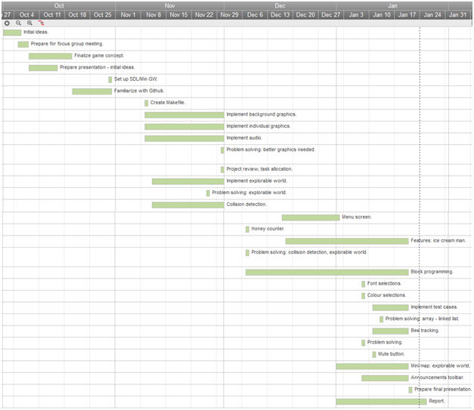

## 5.3 Version Control

GitHub proved an invaluable management tool for degree of contributions made to the codebase, but had its weaknesses: commit count is a poor indicator of degree of code contribution, especially when different aliases of a user are not understood by GitHub to, in fact, be the same commiter. Volume of contribution was also utterly unmeasurable, as contributing image or audio files would indicate a disproportionately large number of ‘code lines’ contributed. Quantity of code lines, in any case, would be at best a weak indicator of feature contribution. All this taken in mind, however, while it provided poor means for ranking contributions, it at least was a great indicator of under-contribution, allowing us to see how best to balance workloads between members throughout development.

## 5.4 Feasibility Study

When determining the success of the project we took into account technical and scheduling feasibility.

### 5.4.1 Technical Feasibility

Varying skill levels in the group were deemed a potential threat to the success of the project. Whilst some group members had a higher skill level, pair programming with less experienced group members and teaching them took up time away from the project.

Another potential threat to the project was the instruction to write it in C language, a language which many of the team had only started learning at the same time as starting the project. Again more experienced members of the team were able to teach less experienced members however again taking time away from working on the project.

The necessity to allow time for familiarising ourselves with the programs we would need to create the game, such as SDL and Github, occurred to us early on in the project and so we ensured to reschedule our Gantt chart and schedule sprints to allow for this. This ensured that each group member had the understanding necessary to contribute to each part of the project.

### 5.4.2 Scheduling Feasibility

With just three months, and a lack of software engineering knowledge, it was difficult to judge a viable schedule of this project. An enthusiastic team meant that scheduling feasibility could pose a potential threat as we began with a large amount of ideas which we simply did not have time to implement in the time scale provided.

From creating a view inside the hive, to spawning different types of bees with different recipes collected from different types of honey, we had a number of interesting ideas which would make fantastic additions to the game in the future, given more time.

We attempted to create a Gantt chart at the beginning of the project however knowing how much time to allocate for each task proved problematic as our lack of experience meant that, with some tasks, we simply did not know how long it would take. A second Gantt chart was produced early on in the project which was a much better validation of these tasks.

## 5.5 Risk Analysis

When planning how to produce a successful project it was important to the team to identify any potential risks involved in order to find solutions to avoid them.

### 5.5.1 Identifying Risks

We identified three main risks when proposing the project:

1. Ambitious Project

The initial game that we proposed was a very ambitious project. A story based game, with an explorable interactive world, a block coding educational element and a huge range of fun, interactive features.

2. Varied Skills and Experience  
  
With everyone in the groups previous background not being in computers, and with the majority of the group having just laid eyes on C programming and SDL at the beginning of the project, it would certainly be a challenge to implement the standard of game we envisioned with the amount of experience we had.

3. Time Management  
  
With just a three month time scale to research, design, build and evaluate the game the time scale of the project was certainly challenging.

### 5.5.2 Risk Management

We identified the following solutions in order to avoid the potentials risks.

1. Ambitious Project.

Whilst the project that we had proposed was ambitious we ensured that we introduced a minimum viable project outlining the minimum amount that we wanted to achieve in the time frame given. This included a well presented, interactive, story based game that worked efficiently, was playable, well polished, educational and fun.

The features that we wanted to have included:

**An explorable interactive world**: this ranked highly in our market research.

**Programmable bees and a block based programming element**: to ensure that our game had an educational element and fulfilled the brief.

**Honey counter**: in order to introduce a competitive element to the game, again ranked highly in market research.

**Graphics**: interesting, eye catching graphics that would make our target audience actually want to play the game.

**Forgiving/Responsive/Depth:** We wanted to make sure that our game was all of these things, which came highly recommended in our market research. We believe that if the game did not meet these requirements then our target audience would not want to play the game and would therefore not learn from the game, thus we are not fulfilling the brief.

2. Varied Skills and Experience

With different experience and skill levels in the group ranging from no previous experience at all to some experience working with C and SDL, it was important for each person to share the knowledge that they had and work on tasks appropriate to their skill level.

These tasks were assigned accordingly; task assignment can be viewed in section 3.6.

We did however want to ensure that every group member worked on every part of the project, so that each individual had contributed to each part and understood how each part of the game worked. We did this through tools such as pair programming, where team members could teach each other based on their area of knowledge. A detailed analysis of how we used this tool and others can be found in section 3.2.4.

3. Time Management

A short time scale and lack of experience would make time management a risk. The lack of experience meant that we were not 100% sure how long each element would take to implement, and therefore it was difficult to schedule each stage of the implementation accurately.

To overcome this issue we worked consistently on the project through weekly sprints and held weekly meetings concerning the project roadmap. This allowed us to work together and see how each element of the game was progressing and also to discuss where we planned to be and where we were at with the implementation stage. If where we were at did not match where we planned to be we would reanalyze what each group member was working on, and redistribute tasks according to our priorities and minimum viable product.

### 5.5.3 Risk Matrix

The team identified the three main risks when conducting the risk analysis; however a risk matrix was also conducted in order to identify less threatening risks.

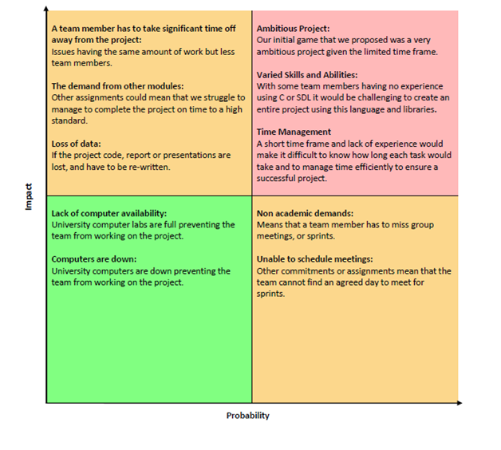

## 5.6 Task Allocation

Tasks were allocated based on individual’s expertise:

* Audio - Sam
* Code architecture – Matt
* Design – Sarah
* Gameplay features – Alex
* Graphics – Jamie
* Testing – Tony

## 5.7 Rescheduling

From our first Gantt chart it is visible that we set out a viable minimum product that we wanted to produce and a list of features we wished this product to have. We allocated tasks and allowed a specified time for each task. However we quickly realized that we had not allowed enough time for problem solving, this process wouldn’t be as simple as completing a task and moving on to the next.

We realized that we did have different levels of ability, not just with coding and SDL, but with using the tools we needed to complete the project, such as Github. Therefore in the second Gantt chart we allocated much more time for the group to familiarize themselves with these tools and a group sprint to ensure each group member had the necessary programs they needed set up on laptops to work on the project individually.

We also set out much more time for problem solving, as implementing a feature successfully one day doesn’t always mean that it will work successfully the next day. We also soon realized that implementing some code on one’s own laptop and running it successfully definitely does not mean that once this code has been pushed to Github it will still run successfully. A great deal of time was needed to review everyone’s contributions and fix bugs so that all contributions worked together.

With much more time spent on problem solving, we had to redefine our priorities and decided that we would much rather have a polished, well presented, working product with less features, with the elements in place to implement these features in the future.

With regards to features we also learnt throughout the project that there were many features we did not take into consideration that were essential to the game, such as a mute button. We then had to make time to implement these options which again cut short the time we had to implement all of the features that we wanted. We are however very pleased that we have the systems in place so that implementing these extended features in the future *should be* an easy process.

## 5.8 Evaluation

[Working on]

# Conclusion 6.0

The underlying frameworks that we have built into Code A Colony provide our game with considerable extensibility, particularly relating to the components that were requested by our sample group. This will allow us, relatively easily, to extend the functionality of our game, and continue to work towards feedback provided from relevant sample groups.

## Further Development 6.1

### Announcement Bar with Story 6.1.1

In our second visit to Bristol Grammar School, we found that a significant missing feature for the pupils was a well-formulated and progressive story. This need was apparent from our very first meeting. Consequently, we had already established an announcement system that the pupils were happy with, particularly with the idea that it should be upgraded to display stages of a story (one that also guides players in a tutorial type fashion).

### Tutorial Mode 6.1.2

A dedicated tutorial mode will also be important for the very first introduction to the game. We noticed in our feedback session that without a bit of initial guidance, the players were initially unsure of how to go about playing the game and what their objectives should be. We have left space for this version of the game in or welcome menu. Although currently the option is inactive, we intend on developing this feature before distributing Code A Colony.

### B++ Editor Extensions 6.1.3

With a means of introducing elements of the game to players, a more sophisticated combination of features could be added. One popular piece of feedback from our second meeting with the pupils was that an ability to write different algorithms for different types/casts of bee would be *“really cool.”* We are also considering the idea of allowing custom function blocks (with custom names) to be added by the player, as a condensed representation for a specific combination of pre-existing blocks. This also relates to feedback we were given that function names could be made easier to understand.

### Alternative Skins 6.1.3

In particular, boys at British Grammar School were interested in the idea of alternative skins. Some of their ideas include space, planet colonization, and an underwater theme. This could be easily achieved with the development of some new graphics, switching the file references around, and recompiling. However an approach that we are interested in facilitating is to allow dynamic switching between themes at the main menu (simple to program but will require additional graphic design efforts).

### Additional Theme Tunes/Sound Effects 6.1.4

Another popular request from our sample group was the addition of more theme tunes and sound effects that related to events in the game. One idea of the pupils was that a *“Jaws theme tune should play when the spider approaches.”*

### Social Media and Element of Competition 6.1.5

Social media and connectivity was a important subject to the pupils we visited. In addition, competition was a concept that ranked very highly as an important game feature. To respond to these two criteria, we have the eventual intention of establishing server connectivity, to allow high scores between players to be recorded and accessible. An ultimate aim that would require significant work, is to develop an online two player version in which multiple colonies compete for limited resources, and launch inter-colony attacks.

### Richness of the Open World 6.1.6

Another piece of feedback given by a pupil was that our navigable world should be developed to have more variety in its scenery. We will work on adding further richness to this world, both graphically and through the addition of more challenges, scenarios and characters.

### Bonuses and Boosters 6.1.7

In order to make the testing of game features easier, over the course of developing Code A Colony we had implement various cheat codes (to get extra bees, to get extra resources, to speed up or slow down day counts etc.). It turned out that presence of cheats was an appealing idea to the pupils at the school. We are not sure whether we will allow cheats in the final distributable, but we will be sure to add extra dimensions to the reward system of the game. Rather than getting extra honey for picking up ice-creams, this could provide bees with an ability to move faster or sense further for a brief period. Other bonus items could be added to extend features of the game in a comical and cheat like fashion.

## Evaluation 6.2

### Code A Colony 6.2.1

The Code A Colony prototype provides sufficient flexibility to allow players to experiment and be creative about the algorithms they implement. For example, an interesting and amusing piece of feedback from a pupil at the Bristish Grammar School was that there should be a special flower or mushroom that the bees can pick up. His idea was that the colour scheme would subsequently turn to rainbow colours, while the bee begins to dance around randomly. The pupil was happy to learn that he could program this behaviour into the bees himself (except the colour scheme changes). As soon as a bee is carrying a flower they begin to dance around in random directions, provided the following combination of blocks is applied: “ifCargo > [integer]” -------- “setHeadingRandomly”.

The game received an enthusiastic and excited response from our sample group, and has sufficient depth to entertain players with a range of different skill levels. The game is also incredibly responsive to minor changes in the algorithm structure, allowing players to quickly see the local and global effects of each action, with a mini-map that showcases swarm behaviour. The gender neutral, cartoon style theme and graphics successfully piqued the interests of both girls and boys, while reinforcing the algorithm focused aims of the national curriculum.

Most importantly we have successfully met the deadline necessitated by this project, while the prototype has been designed for extensibility, to allow the easy addition of story based progression (using the announcement bar) in addition to other developments recommended by our sample group.

### Software Engineering Experience 6.2.2

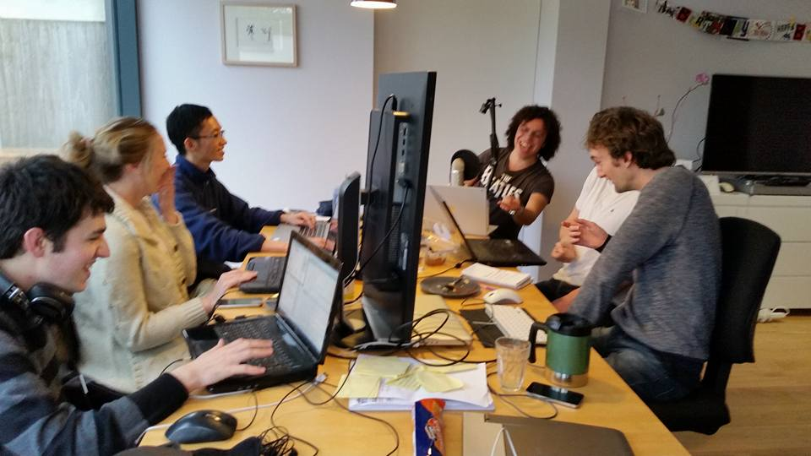

# Appendix

## Market research findings 1.0

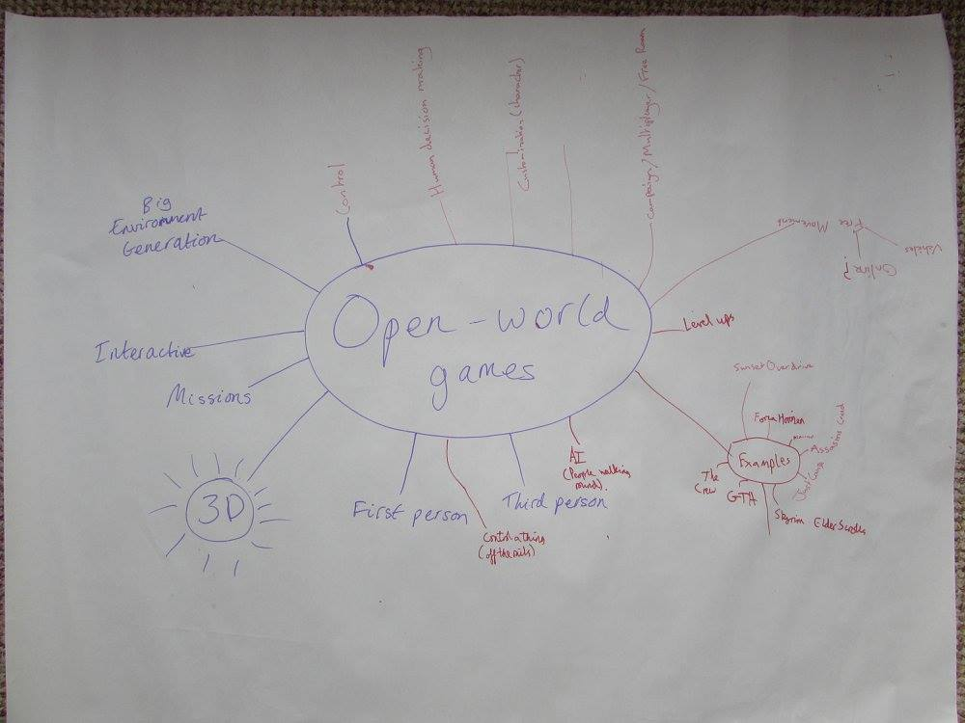

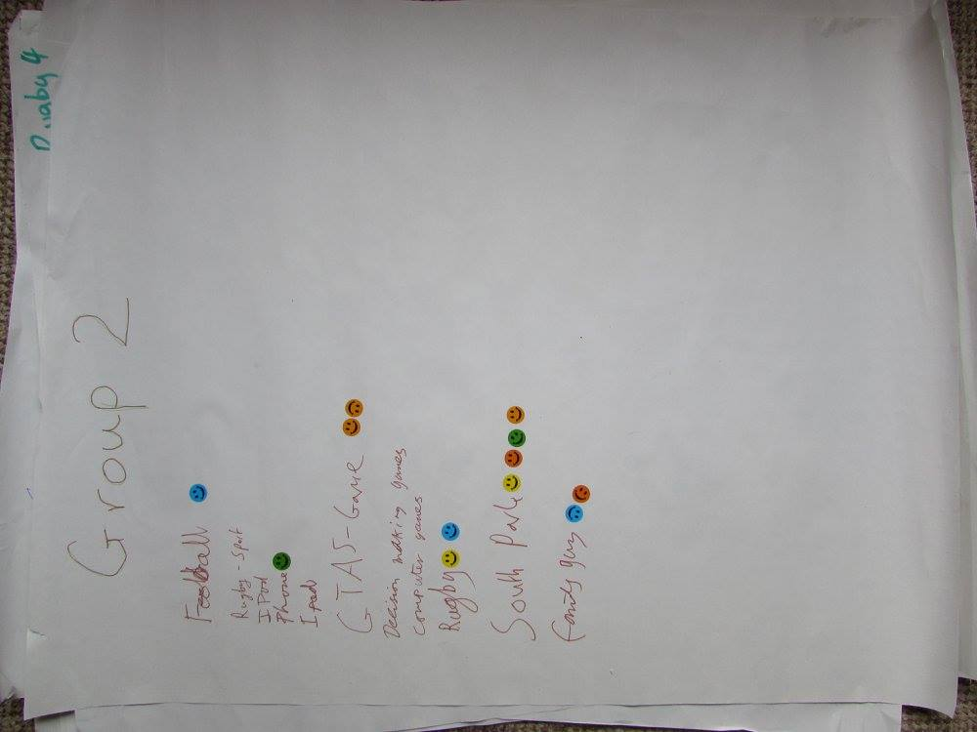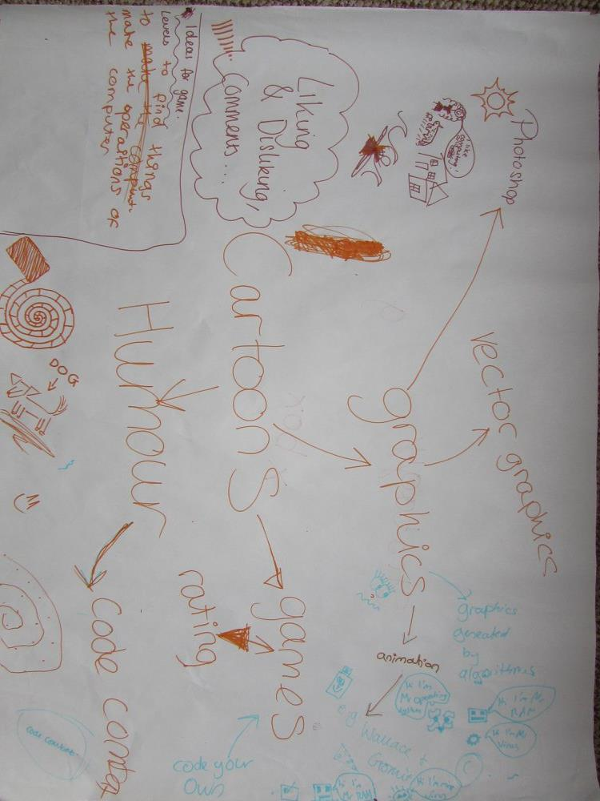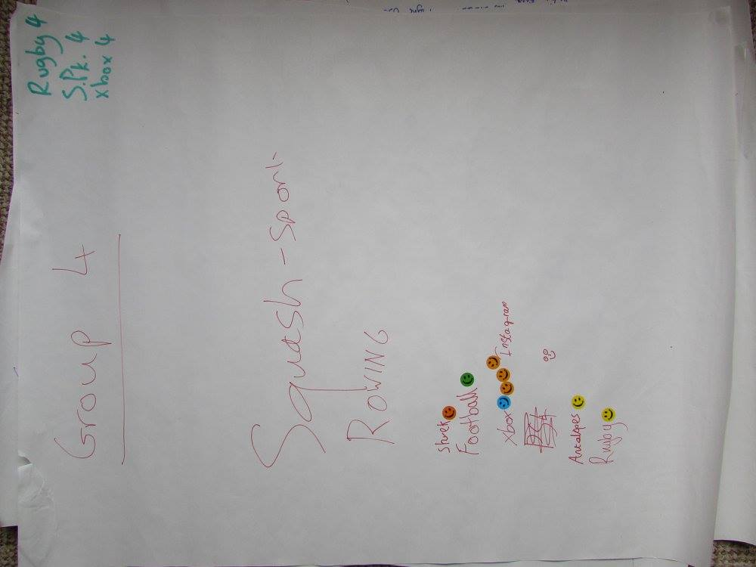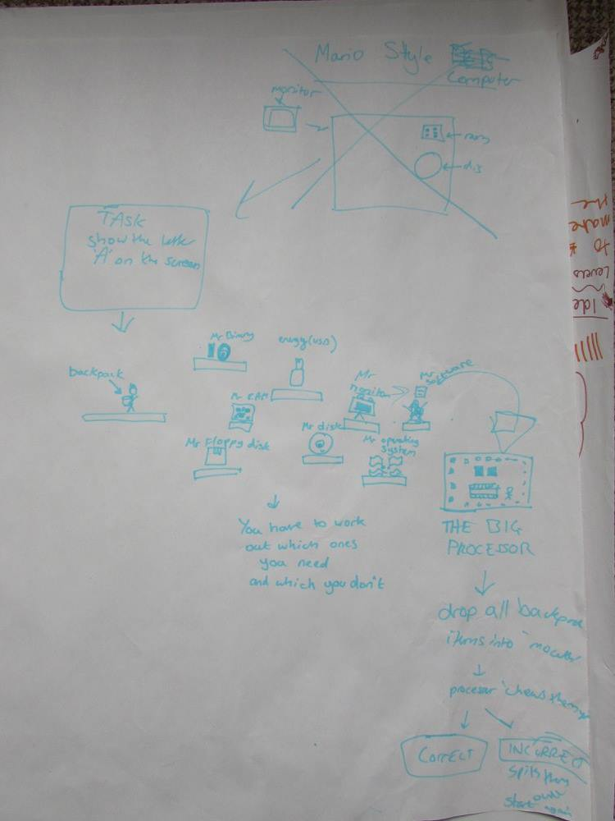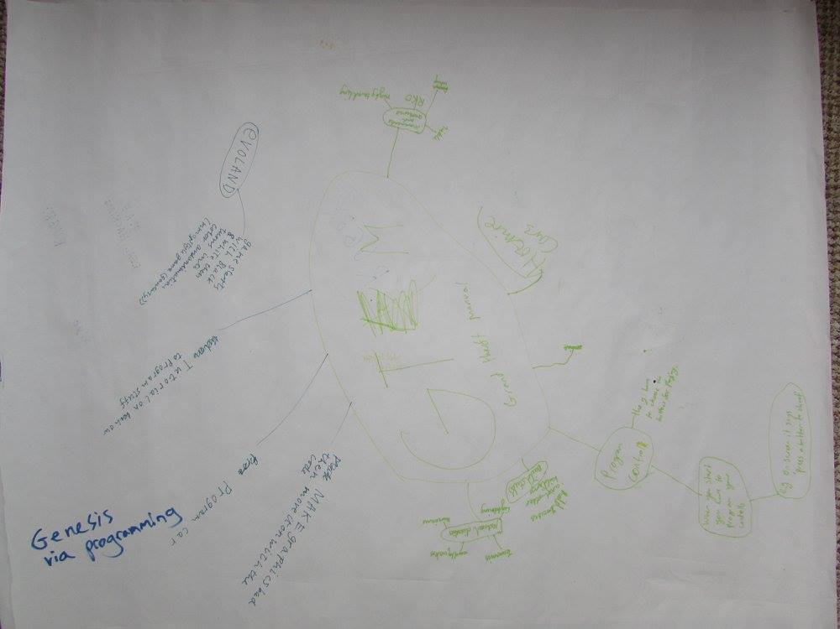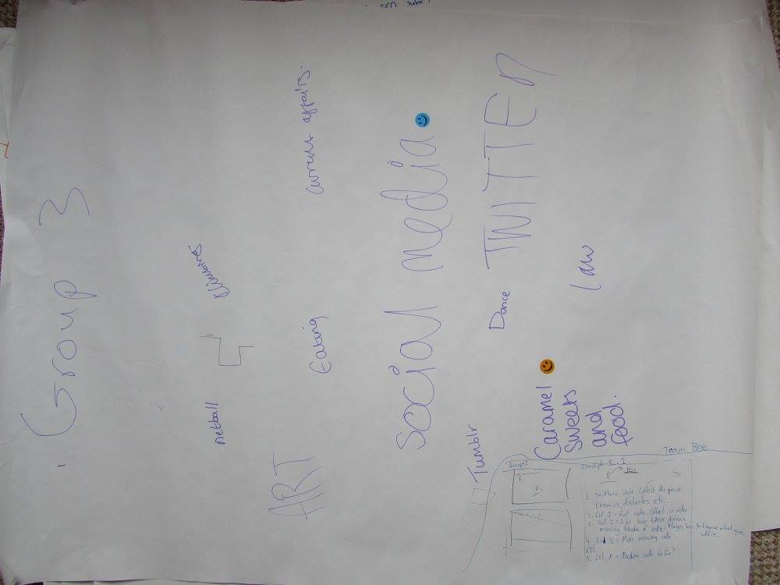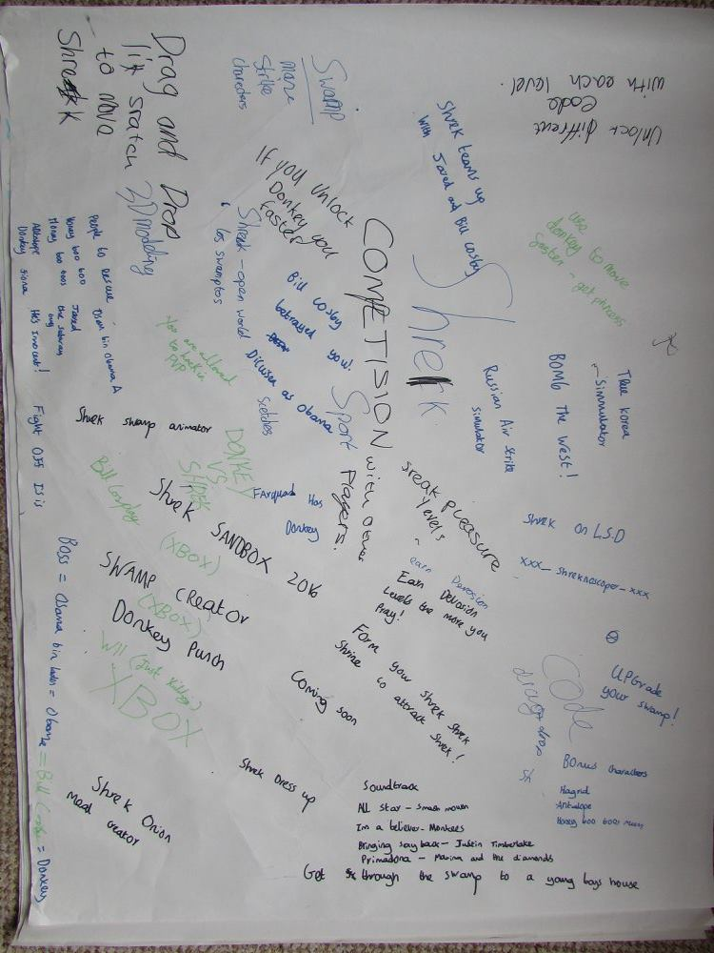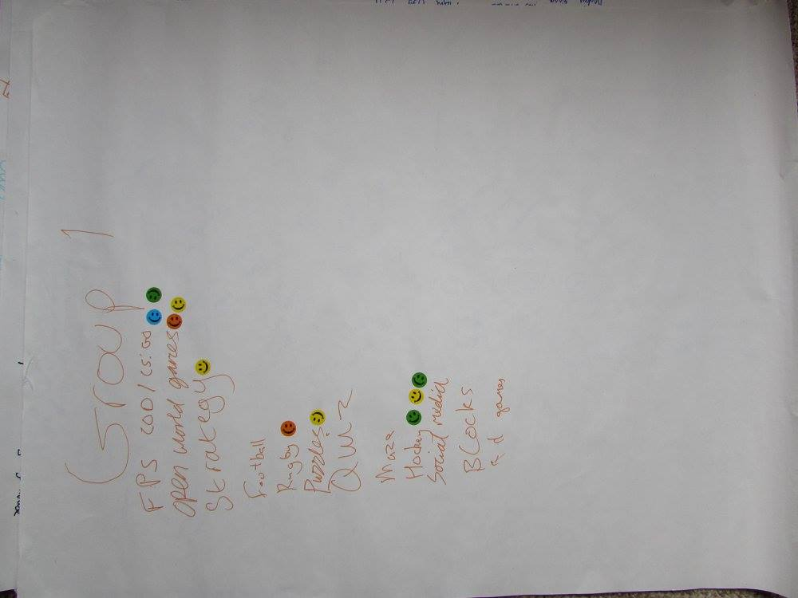

## Meetings materials 2.0

### Meeting one lesson plan 2.1

**Date: Mon 5th Oct, 14:00 - 15:00**

**Purpose:**

Discuss plans and agenda for market research meeting with school kinds, organised by Jamie for Thursday 2:50 to 3:50

**Notes (recorded by Jamie):**

5 5 6 if split into three

4 4 4 4 with us patrolling around

2:50-3:50

* Introduce team: race through names. Display name tags. Don't show already-existing examples yet.
* What is the project, and why we need them.
  + Something appropriate to our abilities, with graphics, in 2D
  + Get young people interested in compsci and tech through a game or puzzle
* What is their current experience of computing? "We know you've done Scratch; what sort of things have you made so far?" Scratch, Small Basic, Flowol. To students and teachers. -> double-check with Roy
* Ask for a mood board ('concept poster') about their contemporary interests and hobbies. Do this as the relay-pen game. Ask Mr. Jones for paper.
* Check which category is the most popular by a tally (each group gets two voting stickers per person).
* /* After meeting: Make a venn diagram to categorise each interest (?) */
* They form groups and design a game. They will be assigned to a topic from the most popular on the board. Must relate to computing somehow. Walk around and take notes on their ideas.
* It's up to them whether to make sketches, etc.
* They present the ideas to the class for comments.
* Any extra time: they ask us qs

**Decisions:**

Time and date agreed for Thursday (2:50-3:50), agenda agreed and rehearsal organised for Wednesday 13:00 (study room in Queens Building Library, booked by Alex and Matt). Colourful dot stickers, pens, and paper need purchasing.

### Meeting two questionnaire 2.2

*Please rank from 1 to 12 the features that are most important to you in a game.*

|  |  |
| --- | --- |
| *Feature* | *Ranking* |
| *Co-operating with other players* |  |
| *Competing with other players* |  |
| *Graphics* |  |
| *Sound design* |  |
| *Single player* |  |
| *Story* |  |
| *Characters* |  |
| *Constant interaction (Eg: CoD vs. SimCity)* |  |
| *Checkpoint-based progression* |  |
| *Replay value* |  |
| *Level-up system* |  |
| *Innovative game mechanic* |  |

If there is another feature you feel is particularly important, but which doesn't fit the categories above, please describe it here: __________________________________________________________________________________________________________________________________________________________

*Please circle the types of game you like to play.*

Strategy, RPG, Action, Adventure, Puzzle, Shooter, Platformer, Sim, Moba, Other _______

## Functions documentation 3.0

Only selected functions are provided, for an illustration purpose.

### Generic.c 3.1

#### int isPointInRect

Syntax: **int** isPointInRect(int point_x, int point_y, SDL_Rect rect)

Function Parameters:

|  |  |
| --- | --- |
| point_x | The x coordinate of the point |
| point_y | The y coordinate of the point |
| rect | A rectangle struct, with dimensions specified |

Remarks: To check whether a point is inside a given rectangle. Returns 1 if it is or 0 if it isn't.

#### int testRectIntersection

Syntax: **int** testRectIntersection(SDL_Rect rectA, SDL_Rect rectB)

Function Parameters:

|  |  |
| --- | --- |
| rectA | A rectangle struct, with dimensions specified |
| rectB | A rectangle struct, with dimensions specified |

Remarks: To check if the two rectangles intersect with each other. Returns 1 if it is or 0 if it isn't.

#### int isRectEnclosedInRect

Syntax: **int** isRectEnclosedInRect(SDL_Rect rectA, SDL_Rect rectB)

Function Parameters:

|  |  |
| --- | --- |
| Rect A | the rectangle that we want to test is enclosed |
| Rect B | the rectangle that we want to see if it encloses rectA |

Remarks: To check whether RectA is inside RectB or not. Returns 1 if it is or 0 if it isn't.

#### void ensureRectEnclosed

Syntax: **void** ensureRectEnclosed(SDL_Rect *ensure, SDL_Rect *limit)

Function Parameters:

|  |  |
| --- | --- |
| ensure | A rectangle struct, with the dimensions to be checked |
| limit | A rectangle struct, with the dimensions of the boundary specified |

Remarks: This function will ensure that the first rectangle is entirely within the other by moving it until there is no collision.

#### float randPi

Syntax: **float** randPi(void)

Function Parameters: Not applicable

Remarks: This returns a random value between PI and 0. It's very useful for working trigonometric randomness.

#### float square

Syntax: **float** square(float f)

Function Parameters:

|  |  |
| --- | --- |
| f | A number |

Remarks: This returns the square of a number.

#### double getDistance2BetweenPoints

Syntax: **double** getDistance2BetweenPoints(float p1X, float p1Y, float p2X, float p2Y)

Function Parameters:

|  |  |
| --- | --- |
| p1X | X coordinate of point 1 |
| p1Y | Y coordinate of point 1 |
| p2X | X coordinate of point 2 |
| p2Y | Y coordinate of point 2 |

Remarks: This returns the square of distance between 2 points.

#### void fitRectToWorld

Syntax: void fitRectToWorld(SDL_Rect *rect)

Function Parameters:

|  |  |
| --- | --- |
| rect | The rectangle with size to be adjusted to fit the world, such as it would not go outside the boundary. |

Remarks:

This function fits the rectangle within the size of the world. So, it won't go outside the boundary.

#### float generateRandomCoordOffset

Syntax: **float** generateRandomCoordOffset(float radius)

Function Parameters:

|  |  |
| --- | --- |
| radius | It specified the offset must be within this distance |

Remarks: This function generates a random x or y offset for a coordinate within a given distance range.

#### double getDistance2BetweenRects

Syntax: **double** getDistance2BetweenRects(SDL_Rect rectA, SDL_Rect rectB)

Function Parameters:

|  |  |
| --- | --- |
| rectA | A rectangle struct, with dimensions specified |
| rectB | A rectangle struct, with dimensions specified |

Remarks: This function calculates the distance between the centre of 2 rectangles.

#### double getAngleBetweenRects

Syntax: **double** getAngleBetweenRects(SDL_Rect *rectA, SDL_Rect *rectB)

Function Parameters:

|  |  |
| --- | --- |
| rectA | A rectangle struct, with dimensions specified |
| rectB | A rectangle struct, with dimensions specified |

Remarks: This function calculates the angle between the centre of 2 rectangles, with the centre of rectA as the base.

#### SDL_Point getCenterOfRect

Syntax: SDL_Point getCenterOfRect(SDL_Rect rect)

Function Parameters:

|  |  |
| --- | --- |
| Rect | A rectangle struct, with dimensions specified |

Remarks: This function calculates the centre of the rectangle, return the dimension of the point as a SDL predefined struct.

#### SDL_Rect getRectFromInvRect

Syntax: SDL_Rect getRectFromInvRect(SDL_Window *window, int from_left, int from_top, int from_right, int from_bot)

Function Parameters:

|  |  |
| --- | --- |
| window | The window screen, SDL pre-defined type - SDL_Window |
| from_left | Pixels from left |
| from_top | Pixels from top |
| from_right | Pixels from right |
| from_bot | Pixels from bottom |

Remarks: This function would calculate the position of the rectangle.

#### SDL_Rect getRectFromPercRect

Syntax: SDL_Rect getRectFromPercRect(SDL_Window *window, double from_left, double from_top, double from_right, double from_bot)

Function Parameters:

|  |  |
| --- | --- |
| window | The window screen, SDL pre-defined type - SDL_Window |
| from_left | Pixels from left |
| from_top | Pixels from top |
| from_right | Pixels from right |
| from_bot | Pixels from bottom |

Remarks: Based on the percentage input (i.e. percentage of length/width as a percentage of whole screen), this function would return the actual pixels of the rectangle by SDL struct.

#### char *fileToString

Syntax: char *fileToString(FILE *file)

Function Parameters:

|  |  |
| --- | --- |
| file | The pointer of the input file |

Remarks: This function would return the string, with contents of string as contents inside the file.

#### SDL_Point getPointFromInvPoint

Syntax: SDL_Point getPointFromInvPoint(SDL_Window *window, int x, int y)

Function Parameters:

|  |  |
| --- | --- |
| window | The window screen, SDL pre-defined type - SDL_Window |
| x | a distance (positive or negative) |
| y | a distance (positive or negative) |

Remarks: This function would return a point: For x, relative to top/bottom of screen for positive and negative x respectively. For y, relative to left/right of screen for positive and negative y respectively.

#### SDL_Point getPointFromPerc

Syntax: SDL_Point getPointFromPerc(SDL_Window *window, double x, double y)

Function Parameters:

|  |  |
| --- | --- |
| window | The window screen, SDL pre-defined type - SDL_Window |
| x | a value as a percentage |
| y | a value as a percentage |

Remarks: This function returns a SDL_Point, with value of point calculated based on percentage of size of screen.

#### void shrinkRectToFit

Syntax: void shrinkRectToFit(SDL_Rect *toShrink, SDL_Rect *fitTo)

Function Parameters:

|  |  |
| --- | --- |
| toShrink | This is a rectangle with size to be adjusted. |
| fitTo | This is an existing rectangle |

Remarks: The dimension of rectangle toShrink is to be adjusted, such that it completely fits inside the rectangle fitTo.

#### int isPointInRangeOf

Syntax: int isPointInRangeOf(SDL_Point point, SDL_Point center, double radius)

Function Parameters:

|  |  |
| --- | --- |
| point | The point to be tested whether it is in circle or not |
| center | The point of centre of circle |
| radius | The radius of circle |

Remarks: This function test whether the point is in the circle or not.

### Controls.c 3.2

#### Static int isMouseFree

Syntax: static int isMouseFree(ControlsData *controlsData)

Function Parameters:

|  |  |
| --- | --- |
| controlsData | A struct containing information related to mouseButtons |

Remarks: This function would return 0 if any mouse button is pressed, and return 1 if no mouse button is pressed.

#### int handleEvent

Syntax: int handleEvent(SDL_Event *event, GameObjectData *gameObjectData, UIData *uiData, ControlsData *controlsData, GraphicsData *graphicsData)

Function Parameters:

|  |  |
| --- | --- |
| event | According to SDL library, SDL_event union is the core to all event handling in SDL |
| gameObjectData | Struct with gameObject data |
| uiData | Struct with UI data |
| controlsData | Struct with controls data |
| graphicsData | Struct with graphics data |

Remarks: This function would execute different events based on user input, including windows, keyboard and mouse events.

#### int keydown

Syntax: int keydown(ControlsData *controlsData, GameObjectData *gameObjectData, GraphicsData *graphicsData, UIData *uiData, SDL_Event *event)

Function Parameters:

|  |  |
| --- | --- |
| controlsData | Struct with controls data |
| gameObjectData | Struct with game object data |
| graphicsData | Struct with graphics data |
| uiData | Struct with ui data |
| event | According to SDL library, SDL_event union is the core to all event handling in SDL |

Remarks: This function is part of the handleEvent, dealing with events when users press a keyboard button.

#### int keydown

Syntax: int keydown(ControlsData *controlsData, GameObjectData *gameObjectData, GraphicsData *graphicsData, UIData *uiData, SDL_Event *event)

Function Parameters:

|  |  |
| --- | --- |
| controlsData | Struct with controls data |
| gameObjectData | Struct with game object data |
| graphicsData | Struct with graphics data |
| uiData | Struct with ui data |
| event | According to SDL library, SDL_event union is the core to all event handling in SDL |

Remarks: This function is part of the handleEvent, dealing with events when users release a keyboard button. It is required for certain keys, such as arrow keys. (For example, the map stop moving towards left when the user release the left button.)

#### void panScreen

Syntax: void panScreen(GraphicsData *graphicsData, ControlsData *controlsData, int delta_t)

Function Parameters:

|  |  |
| --- | --- |
| graphicsData | Struct with graphics data |
| controlsData | Struct with controls data |
| delta_t | Time in milliseconds |

Remarks: The screen would have a navigation offset based on user input (pressing left, right, up or down key).

#### void initControlData

Syntax: void initControlData(ControlsData *controlsData)

Function Parameters:

|  |  |
| --- | --- |
| controlsData | Struct with controls data |

Remarks: Initialize controls data, including no pressing on all keyboard and mouse buttons.

### AI.c 3.3

#### int countCharsInString

Syntax: int countCharsInString(char *string, char countChar)

Function Parameters:

|  |  |
| --- | --- |
| string | The string to be counted |
| countChar | The specific character to count |

Remarks: This function would count the number of that particular character that appeared in the string. For example, there are 2 ‘n’ in string “funny”.

### World_generation.c 3.4

#### void generateResourceNodeSpawners

Syntax: void generateResourceNodeSpawners(GameObjectData *gameObjectData)

Function Parameters:

|  |  |
| --- | --- |
| gameObjectData | Struct with game object data |

Remarks: This generates the resource (i.e. number of honey) contained in each resource node (i.e. the flowers). It is stored as an array in gameObjectData.

### Graphics.c 3.5

#### void paintWeatherLayer

Syntax: void paintWeatherLayer(GraphicsData *graphicsData, enum WeatherStatus present_weather, SDL_Texture *texture)

Function Parameters:

|  |  |
| --- | --- |
| graphicsData | A struct with graphics information |
| present_weather | Current weather status |
| texture | Predefined SDL type texture |

Remarks: This function creates a Weather struct and fills in the default values. The possible weathers are: Rain, Sun, Snow, Cloud. It would also call SDL to draw color, draw blendmode, set texture and fill the rectangle.

1. https://www.nesta.org.uk/sites/default/files/the_legacy_of_bbc_micro.pdf
2. http://www.ebuyer.com/blog/2015/07/can-the-bbcs-micro-bit-inspire-a-generation/
3. http://www.theguardian.com/media/interactive/2011/aug/26/eric-schmidt-mactaggart-lecture-full-text
4. https://www.gov.uk/government/uploads/system/uploads/attachment_data/file/239067/SECONDARY_national_curriculum_-_Computing.pdf
5. https://www.gov.uk/government/uploads/system/uploads/attachment_data/file/239067/SECONDARY_national_curriculum_-_Computing.pdf
6. http://www.computerweekly.com/feature/The-UKs-new-computing-curriculum-is-here-Are-teachers-ready
7. http://schoolsweek.co.uk/teachers-lack-confidence-in-computing-science/
8. http://schoolsweek.co.uk/3m-on-and-where-are-all-the-master-teachers/
9. http://www.theguardian.com/technology/2014/sep/04/coding-school-computing-children-programming
10. https://petition.parliament.uk/petitions/111693
11. http://www.bbc.co.uk/news/technology-29010511
12. <http://www.nesta.org.uk/sites/default/files/next_gen_wv.pdf> p.38
13. <http://www.nesta.org.uk/sites/default/files/next_gen_wv.pdf> p.5
14. <http://www.nesta.org.uk/sites/default/files/next_gen_wv.pdf> p.38
15. https://www.gov.uk/government/uploads/system/uploads/attachment_data/file/239067/SECONDARY_national_curriculum_-_Computing.pdf
16. http://www.bbc.co.uk/iplayer/episode/b03k6ypz/the-joy-of-logic
17. http://www.bbc.co.uk/programmes/p030s6b3
18. Secrete rules of modern living, bbc, marcus du sautoy
19. http://journals.plos.org/plosbiology/article?id=10.1371/journal.pbio.1001392
20. Secrete rules of modern living, bbc, marcus du sautoy 00:48:35
21. http://wiki.scratch.mit.edu/wiki/Development_of_Scratch_1.0
22. http://wiki.scratch.mit.edu/wiki/Artificial_Intelligence
23. http://snap.berkeley.edu/run
24. http://blogs.msdn.com/b/ukschools/archive/2010/04/15/kodu-for-pc-a-teacher-s-tutorial.aspx
25. http://www.alice.org/index.php?page=what_is_alice/what_is_alice
26. https://lightbot.com/hocflash.html
27. https://www.kodable.com/
28. http://www.robozzle.com/
29. http://twolivesleft.com/CargoBot/?utm_campaign=Listly&utm_medium=list&utm_source=listly
30. http://www.codewarriorsgame.com/kai-web-kai/login
31. http://armorgames.com/play/12841/swarm-control
32. http://www.swarmcontrol.net/
33. http://blog.soulwire.co.uk/laboratory/flash/as3-flocking-steering-behaviors
34. GPU-Z is a tool for monitoring graphics card variables, such as temperature, clock-speed and load.
35. Game of Thrones, Season 1, Episode 1: Winter is Coming – Quote: “Winter is Coming.”
36. For example, Amiga game Rainbow Island’s 16-bit version “somewhere over the rainbow”.
37. Ain’t No Sunshine (1971) – Original Artist: Bill Withers
38. Summertime (1934) – Original Artist: George Gershwin
39. Black Horse & A Cherry Tree (2005) – Original Artist: KT Tunstall
40. Paul McCartney – Rupert and The Frog Song (1986) – Animated Movie